Comments on MIDAS data set

M. Hecht

March 31, 2012

1. The **Coordinate System** document is very helpful. A few improvements and changes are needed:
   * 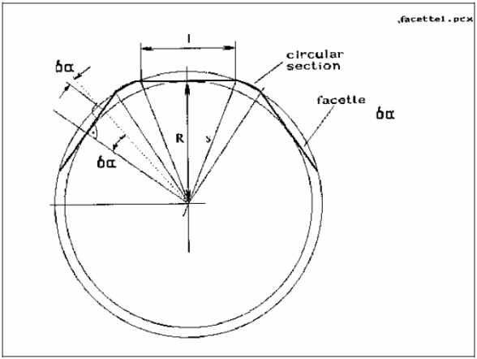The term “row” is used a number of times, but is not defined
   * Figure 3 (if I understand it) is so badly out of scale as to be deceptive. I suggest that instead of showing a full disk with oversized facets, simply show a small segment of arc with a realistic radius of curvature.
   * There are still TBDs and TBCs in the definition of the AFM Reference frame
   * It is stated that the reference position of the encoder corresponds to the center position of facet #1. Is this a good choice given that the reference position corresponds to the origin of the scan (e.g. a scan taken at the reference is in the upper right quadrant)?
2. The **User Manual**
   * Also very useful, though not always well tied to the dataset formats.
   * Repeatedly refers to “silicon” damping material, where *silicone* is clearly intended
3. The **ICD**

**General comments**

* Scans are grouped into “observations.” The total information set for a given scan is thus contained in a set of files with: A prefix (HK_, IMG_, etc.); an observation designator (reflecting start and stop times); a scan number; and a suffix (reflecting extra information such as Channel ID). The most important are the IMG file, the HK files, and their corresponding label files. While this is implied in ICD Section 3.1.5 (File Naming Conventions), it should be clarified specifically at the start of the document.
* There is a general lack of narrative information. Much of the essential information is contained in PDS OBJECT descriptions, which are often generic, such as “Textual description of the event.” In that example, it would be useful to know what type of events might be captured in these records.
* The filename contains a “sequence number,” and there are otherwise identical filenames with successive sequence numbers. Apparently a single “observation” can contain multiple successive scans. This needs documentation.
* The authors seem to assume that users will use the IDL software alone. This software appears to collate and link the disparate information that makes up the context of the scan. It is strongly recommended that the documentation be adequate for users of other software to reconstruct the same information.
* The use of the term “target” to refer to the substrate or coupon being imaged is ubiquitous. Unfortunately, it is also used to refer to the astronomical object under study (in TARGET.CAT, for example). It may be desirable to resolve this conflict.

**Section 2.4 (Overview of Data Products)**

* + **Single Point Approach Data** seems to describe a line scan rather than an approach. I can see how it might be applied to an approach, but this should be made explicit.
  + **Image Scan Data** description is inadequate, considering that this is the primary data product. Specifically:
    - There is no discussion of scan algorithms. Like a typewriter, an AFM scan must return to the start of every line (though some scan in a serpentine fashion). Typically data is collected during the return scan and interleaved “forward” and “backwards” images are acquired. If not, it is useful to indicate whether the data in the IMG file represents forward or backward. Also, as a result of the scan pattern and the possible need to stabilize the mechanism before beginning a new scan, either “scan speed” does not represent the actual time between data points, or else the product of scan speed and number of points does not equal the scan duration. This also should be documented.
  + **Target Utilization History Data:**  It is stated that each target is subdivided into 16 addressable segments, but doesn’t indicate the geometry of this subdivision (a figure would be helpful).
  + **Software** (2.4.6) describes archiving of IDL-based routines in the PDS, which seems contrary to my understanding of PDS policy, as least how it was implemented for the Phoenix mission (with respect to Matlab-based routines). It was explained at the time that there is no guarantee that these routines will continue to operate as the closed-source environment evolves.

**Section 3.2.4 (Other Applicable Standards)**

* + Oddly, this is where the description of the IMG format is found. It should be placed in a more appropriate Section.
  + The IMG format includes several optional header items, among them “current,” which defines the tunneling current – a parameter inapplicable to an AFM. Extraneous parameters such as this should be removed from the description if they are not part of the MIDAS dataset, or at least prefaced by an indication that they are part of the SPIP standard but not used here.

**Section 3.4.2.2 (Calibration Directory)**

* + Here, description and offsets are listed but there is not description of the governing equation, hence the sign of the offset is unclear. It can be inferred that “value = data*calibration factor + offset,” but this should be explicit.
  + Within the “description” column are (presumably) parenthetical ranges, but this is not indicated in the column header.
  + Many calibration values don’t indicate data type (real, integer, etc.) or number of bits. This is presumably in the corresponding detailed descriptions, but a prose description would be appropriate as well since the data word type does not necessarily reflect the content (e.g. a 16-bit unsigned value may only have 12 bits of useful information).

1. **IMG** files
   * The format has been chosen to conform to the proprietary SPIP data analysis program popular in the scanned probe community. However, the file description in the ICD is inadequate for users to develop their own code to read it. I was able to do so, somewhat by trial and error, determining the following:
     + Keywords are in the format “name=value,” one per line, with a space preceding and following the “=,”and with the value followed immediately by a <CR/LF>
     + The keyword list is padded to 2048 by a single string of zeros (not spaces).
     + The data is written in little endian format (indicated by the “intelmode=1” parameter), in 16-bit integers. The integers seem to be unsigned*,* as suggested by the LBL file SAMPLE_TYPE keyword value, “LSB_UNSIGNED_INTEGER.”
     + The data seems to be written in rows, with the first value representing the upper left of the image.
   * There should be a common section of the ICD with a complete description of the IMG file, rather than require the user to assembly the information from various sections. Some of the relevant information is only found in the User Manual (Section 3.1.9.2), such as these bullets:
     + Each value is stored in one word (16 bit).
     + All data acquired during one scan constitute a data set, i.e., a data set may contain up to 8 individual images.
     + The minimum size of an image is 32x32 pixels, filling 1024 words which corresponds to one image data packet.
     + The maximum size of an image is 512x512 pixels, filling 262144 words which corresponds to 256 image data packets.
   * The above might suggest that a single .IMG file may contain multiple channels. However, ICD Section 4.1.2 (Data Product Preparation) indicates that the IMG file has “one file per image and image data type.”
   * I couldn’t find anything about completion status (it wouldn’t be unusual for a scan to be interrupted by, e.g., thermal drift taking the surface out of the narrow range of the z-piezo). DATA-QUALITY_ID and DATA_QUALITY_DESC in the IMG LBL file (ICD Section 4.2.3) seem to distinguish only “good” and “bad” data.
   * I couldn’t find Channel Number (or the equivalent 2-letter code) or sequence number in either the LBL file or the IMG file header (unless it’s under MIDAS_SCAN_DATA_TYPE), only in the filename. It would be useful to have as a keyword, since filenames can be (and often are) changed by users.
2. **HK and HK2** files
   * A dictionary describing HK items in detail would be very helpful. These items are critical for interpreting the images, and in the present documentation there are only a few words associated with the DESCRIPTION keyword in the LBL file .
   * It would be useful to have specific information (or a pointer to another file) indicating operation of other spacecraft systems that might be sources of microvibrations, as described in Section 3.1.5 of the User Guide.
3. **Target History (TGH)** files
   * These files are named (TGH_xxx_nn). Under “Filenaming Convention” the ICD indicates that the “nn” above refers to “facet number.” The Lutetia dataset includes three TGH files, for facets 01-03. The label in each of the three .IMG files in the Lutetia set refers to “ROSETTA:MIDAS_TARGET_NUMBER = 37.” This introduces several problems:
     + Are “targets” and “facets” the same thing? If so, pick one term. Preferably that term is “facets,” since the same IMG label also includes the keyword “TARGET_NAME = "(21) LUTETIA." That change might also mean changing the designation “TGH” to FCH, for example.
     + Assuming that facets and targets are the same, then the facet used for the Lutetia observation (37) was not included in the dataset. ***Therefore the dataset is not complete and cannot be certified.***
     + In addition to the filename designation, there should be a keyword in the TGH LBL file indicating the facet number.
     + There is no information in TGH files indicating what segment or coordinates were previously scanned. This is important both for change monitoring, and in recognition of the fact that the scan itself can (and usually does) modify the target.
     + Presumably, in addition to “Scanning” there will be fields designating “Exposure,” or “shutter open/close.” This should be documented in the ICD.

**Appendix**: I was able to successfully plot IMG files using software *other than* the IDL supplied routines.

Image #3: Raw and derivative plots from Matlab (range not entered on axes). Data has been read Little Endian, complemented and flipped to agree with SPIP rendering conventions.



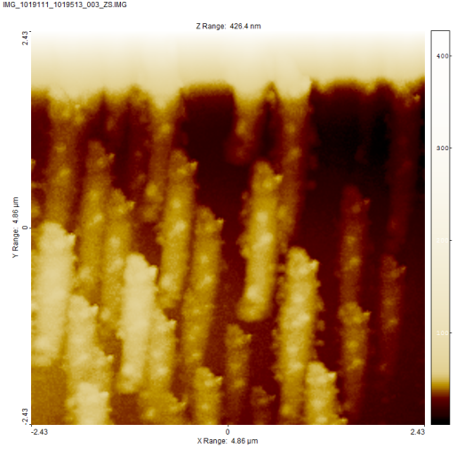Image #3 rendered with ImageJ, a free open-source program (below left) and with SPIP (below right):

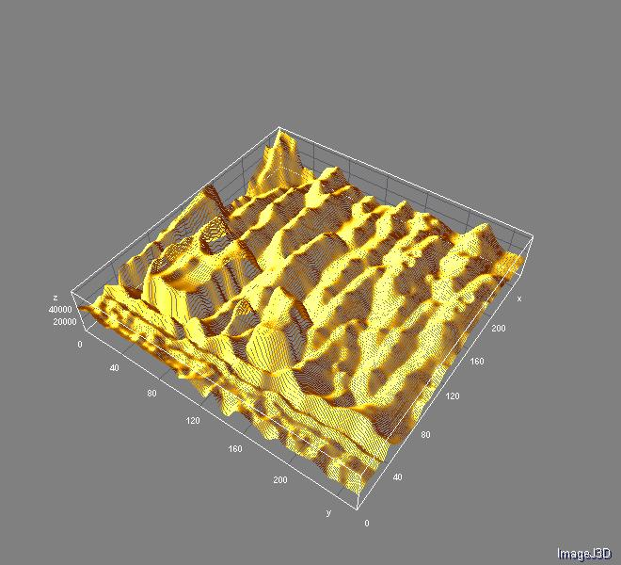

Image #3 (below), cropped and rendered in 3D in SPIP

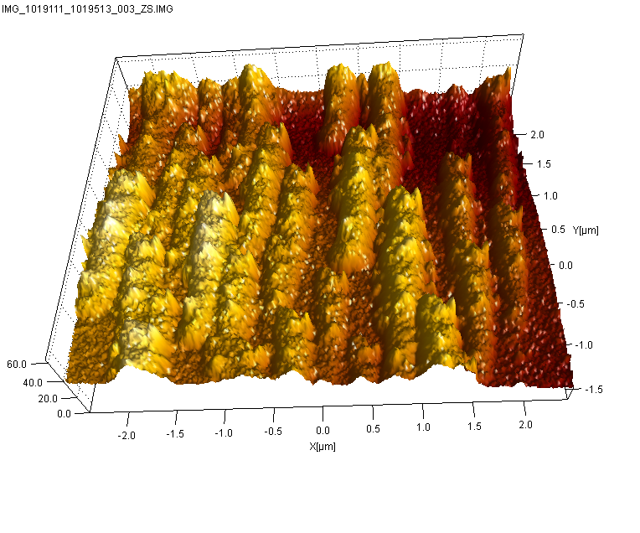

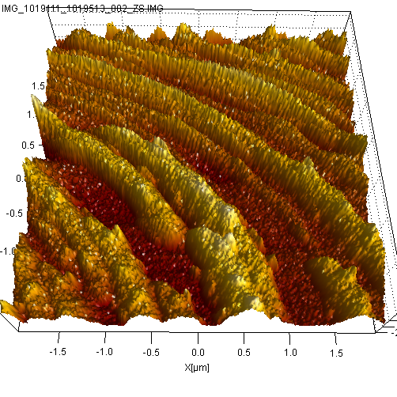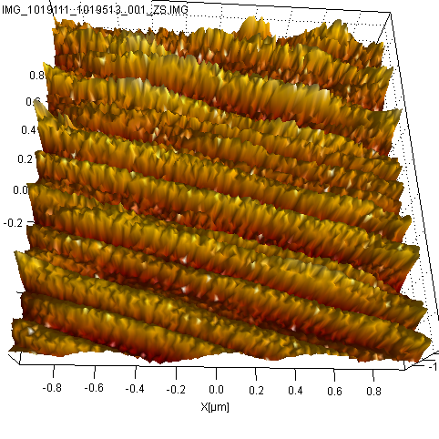Images #1 and 2 (below) were heavily bowed, but could be displayed in 3D after flattening with SPIP software.