Minor issues: under data for the dsk and wrl model:

Labels should possess some information on when then the shape model created. It is in the higher level documentation; but it would be helpful.

Also, it would be really helpful if some information was provided on what images went into making the models provided. Not all images available are typically used. Even better would be some information on the range of incidence and emission angles the images had. And what number of images might have been used per region of the comet. This would allow a user toknow what the limitations of the data might be, so they can assess the precision and accuracy of the shape model.

Shouldn’t the label state how many vertices and facets are present in the wrl model. That would be helpful. It is mentioned in the file names, but it would be convenient to have it in the label too.

What is this? “and ???????” in label for reference

Confirmation that models worked:
I was able to view the wrl shape model with no trouble in paraview.

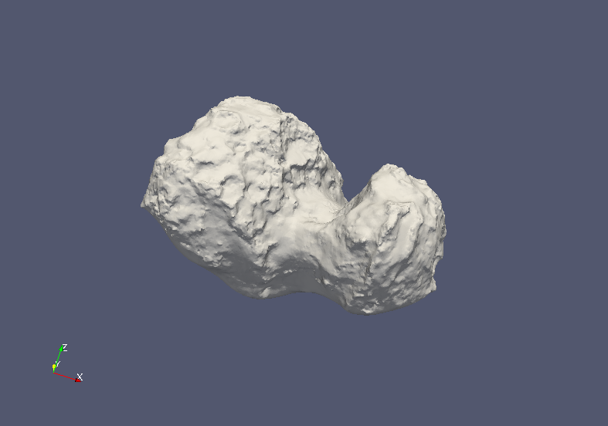

I was able to convert the wrl file and then view it in obj format. Here it is in the small body mapping tool.

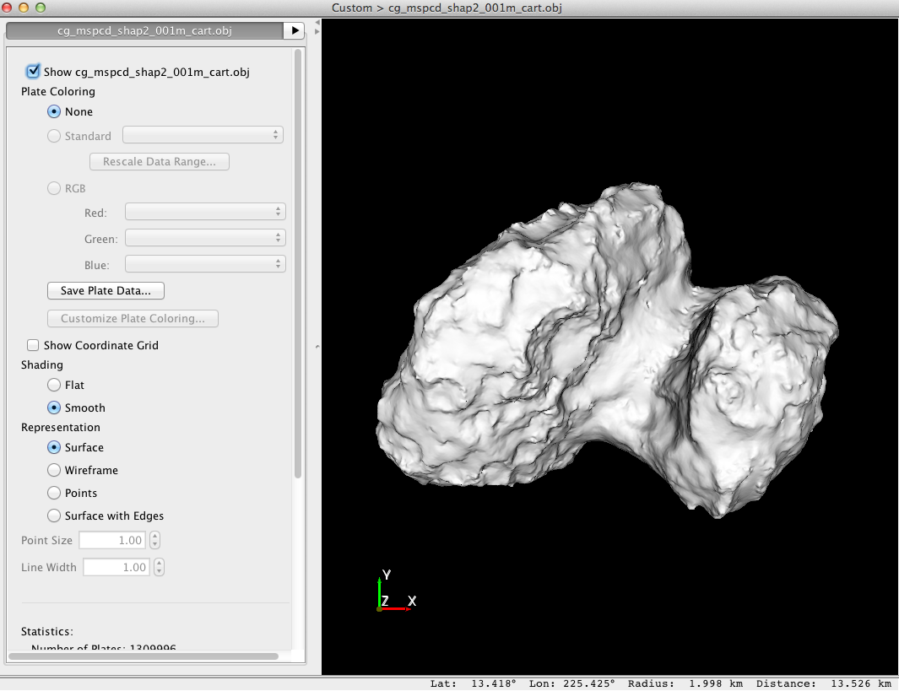

The DSK files seem to work great too:

I was able to generate the following fake image of the asteroid with one of the dsks.

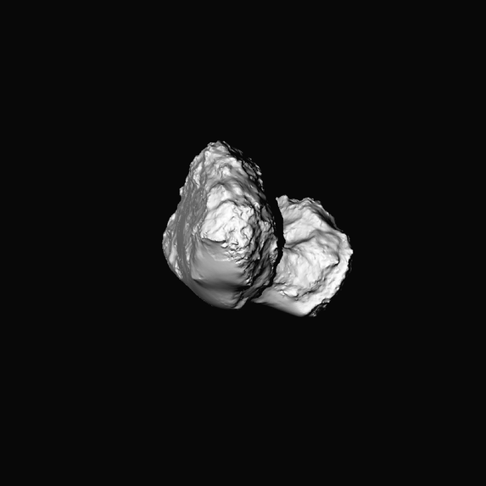

The DSK worked with no issues. No errors are warning were created in the spice tool set.

Olivier

