New Horizons REX Data Set Review
Reviewer: Dustin Buccino

Summary

The Level 2 and Level 3 REX datasets from the New Horizons Pluto encounter are well documented and referenced. The standard format FITS-packed data are easy to extract and analyze. The comments below are mostly clarification and to improve ease-of-use.

Data

- The FITS-packed data are well documented and labeled. The standardized format and similarities between the datasets make it easy to extract the relevant data
- I was able to interpret a set of the data files using the provided python code sample
  - newrex_py.py uses “pyfits” library but only “astropy” is referenced in aareadme.txt, “astropy.io.fits” is functionally the same as “pyfits”, so I needed to slightly modify the code to account for the library change
  - I confirmed the IQ and radiometer values match in the *.fit/*.asc sample files in the document/samples/ directory
  - I was able to get frequency and power estimates from the IQ data using pre-existing software tools from Side A (see below), which look appropriate
Level 2 Dataset  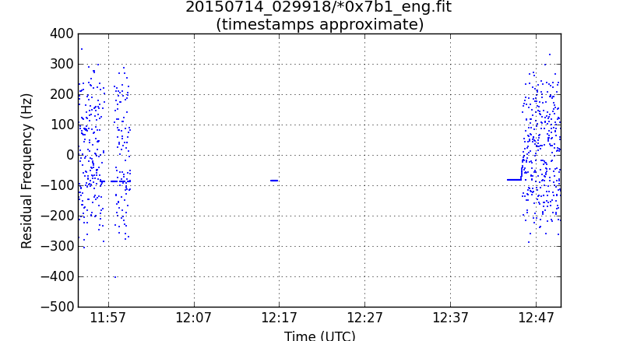  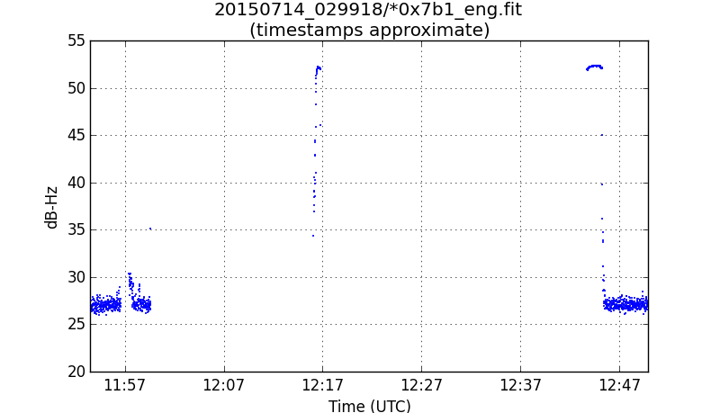 | Level 3 Dataset  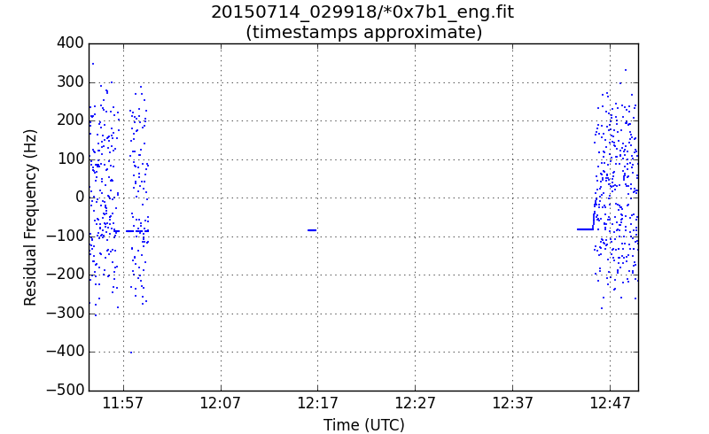  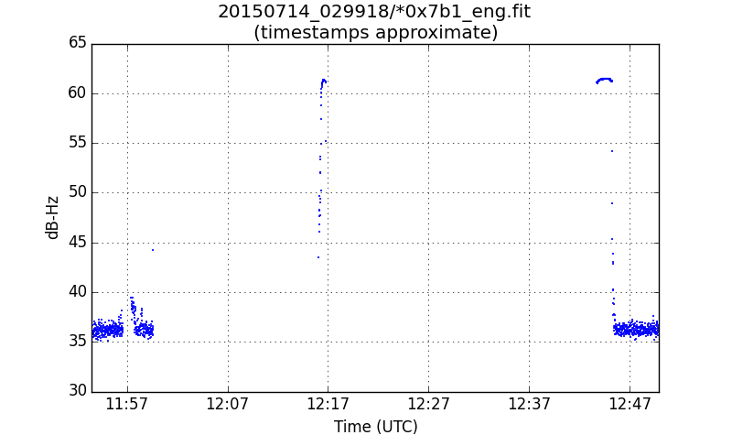

- I was unable to find any documentation in the archive on how to compute a sky-level frequency from the observed frequencies. The rex_ssr.pdf and rex.cat files goes into some detail on RF system but there is no obvious equation or method shown
  - The telecom papers referenced in rex_ssr.pdf go into the RF/IF system in detail (but are not included in the archive)
- The level 2 and level 3 dataset share nearly identical documentation, which I think is appropriate after reading on the calibration scheme and the difference between the two datasets

File Specific Comments

These comments, unless otherwise noted, apply to both the level 2 and level 3 dataset, due to the similarities between the datasets.

Filename | Comment
aareadme.txt | - Once the tracking dataset (for gravity studies) is complete it would be useful if the aareadme.txt was updated with the data set ID of this dataset so users can find it quickly (and vice-versa, the tracking dataset should have the data set ID which contains the REX data)
catalog/dataset.cat | - First paragraph, second line should be tabbed or additional newlines should be added to separate it from the rest of the paragraph  - Filenames/Product IDs naming convention description is not tabbed properly (the arrows don’t align with the filename)  - The notes from the aareadme.txt naming convention should also be in the dataset.cat naming convention, i.e. Note FN1 and FN2.  - dataset.cat lists in the Software section that no special software is included, but there are code samples in the document/codesamples/ directory
catalog/nhsc.cat | - Section on propulsion mentions a “Figure 5” but there is no such figure in the catalog file
catalog/rex.cat | - There are two headers for “INSTRUMENT OVERVIEW – FLIGHT ELEMENT”  - DSS-35 was operational in 2015 but is not listed in the “Subsystems – DSN” section or “Location – DSN” section. (No need to add it unless DSS-35 was used by New Horizons)  - Under “DSCC Transmitter Subsystem”, the last sentence says power levels above 20 kW are available only at 70-m stations. 80 kW transmitters are being installed at the 34-m stations, and some are operational today. Was the REX experiment limited to the 20 kW transmitters?  - Acronyms section, “NIST” says “SPC 10 time relative to UTC [???]”, with question marks. (National Institute of Standards and Technology?)
document/docinfo.txt | - It would be helpful if the document listing were in alphabetical order so they appear in the same order when listing the directory
document/codesamples/codeinfo.txt | - IDL and Python notes that it requires supporting libraries. The libraries are listed in aareadme.txt but would be beneficial to also list here.
data/yyyymmdd_tttttt/*.lbl | - The SPICE_FILE_NAME includes CK and SPK. Were only time transformations applied?

