SWAN Water Production Rates Review Comments
Scott Budzien, Naval Research Laboratory

Summary
As a stand-alone data set providing cometary water productions rates for a series of comets near perihelion, the data includes all required information to understand the final data products. The table data files provide time, heliocentric distance, spacecraft distance, g factor, and Q(H2O) with uncertainty. The documentation provides an adequate description of the mission, spacecraft, sensor, observations, and an overview of how the derived data products were calculated. Moreover, sufficient journal references are included for the user to understand the details of the data analysis process and final production rates. As such, the data provides a usable dataset for scientific investigations.

Comments on the Data Tables
In terms of having a stand-alone dataset that includes all relevant input data used to create the dataset, there are a few missing pieces. The missing data could be tracked down by a user, but without the exact values used for the dataset, the final results might not be exactly replicated.
- Ephemeris for the spacecraft is not present in the dataset. Is an average value for R(L1) used or were exact values calculated?
- Ephemerides for the comets (providing R, Rdot, ra/dec) are not provided. Rdot is a key parameter used to calculate the excitation efficiency (g-factor): the g-factor is provided, but R-dot is not provided.

The calculated g-factor includes a number of terms that must be accounted for:
- Solar Ly-a flux is another key parameter not provided. What is the measured solar Ly-a flux value used? The reference paper Combi et al 2011 states that the Earth-measured flux is adjusted for solar rotation. However, the amount of solar rotation adjustment depends upon the longitudinal difference between the comet and the L1 location. This longitudinal shift cannot be calculated from R and L1-comet distance alone.
- Secondarily, the solar latitude of the comet weakly relates to the effective Ly-a flux and g-factor. Due to a latitudinal distribution of solar active regions, flux measurements at earth may differ from that “seen” by the comet, particularly in highly inclined orbits. This adjustment factor may not be well-known or well-estimated, but this solar latitude information may be useful for assessing production rate uncertainty or interpretation caveats.

Some relevant lower-level data values are not included, such as
- Raw brightness counts, or raw brightness in Rayleighs
- Raw background counts, or effective background in Rayleighs.
- The calibration and calibration reanalysis was mentioned, a reference was provided, but calibration values are not included in the dataset. The calibration factor varies over time and relative calibration shift has been monitored using UV stars. Calibration value would be useful, since the dataset was collected over such a long period of time.
- What is the total column brightness in Rayleighs and the calculated background? This value would facilitate reanalysis or reinterpretation of this data set in the future.

Comments on the Labels
In the data labels, the g-factor description should specify 1AU for the g-factor reference distance.

Also, the production rate and production rate uncertainty do not include the factor of 1e27 in the units (1e27 molecule/s).

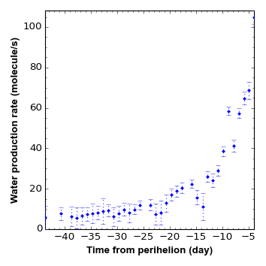
Comet 2P/Encke 2013
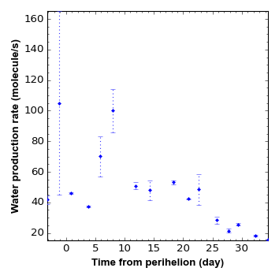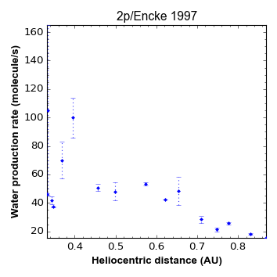
Comet 2P/Encke 1997
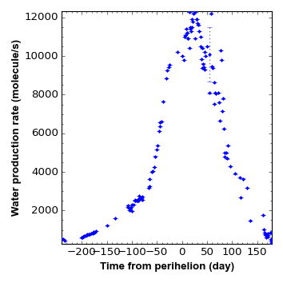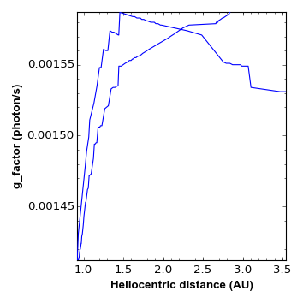
Comet 1995_O1 Hale-Bopp

