Documentation:
From ICD

- Hyperlinks in TOC don’t work, section label wrong
  - Hyperlink for 13. SDC…
  - Hyperlink for (13).1 Overview – mislabeled
- On p. 127, 13.2.4 – it says “See section 115” – not sure what this is referencing
- On p. 129, last sentence before plot – “See for a plot of Charge …”
  - Should be referencing “below”, Fig 13-2, other reference
- On p. 130, equations are formatted wrong (“Y” appears throughout the equation where there should be a symbol indicating multiplication)
- On p. 130, hyperlink to ResearchGate.net not very helpful without more info on James et al 2010 paper.
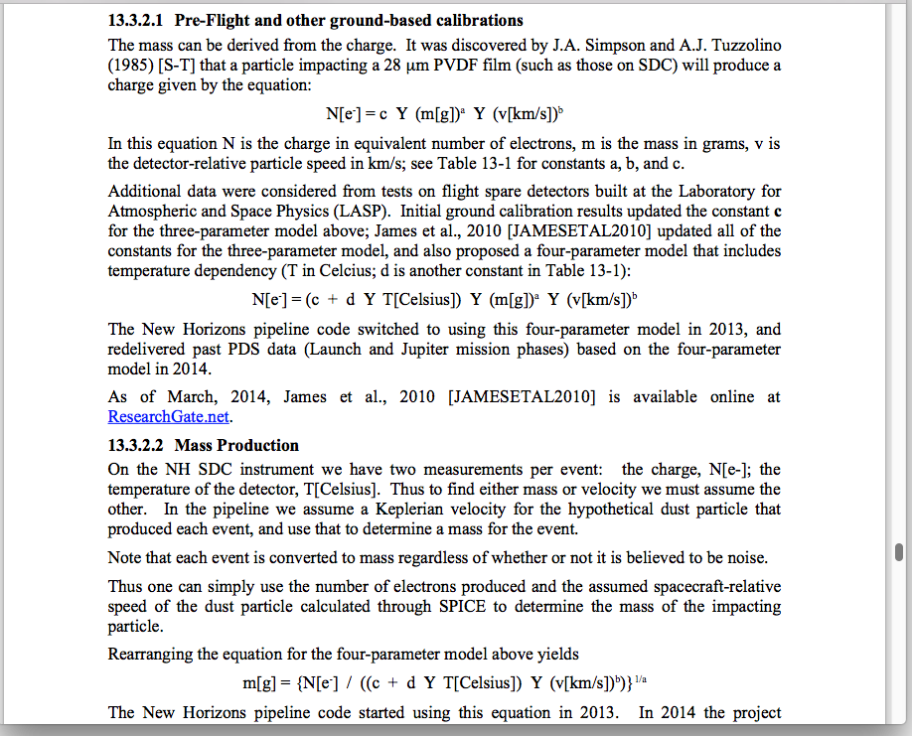

aareadme.txt
- Should the “skel …” lines remain in this doc?

calib/…cal_matrix….tab
- Cel[c]ius is spelled wrong in every instance
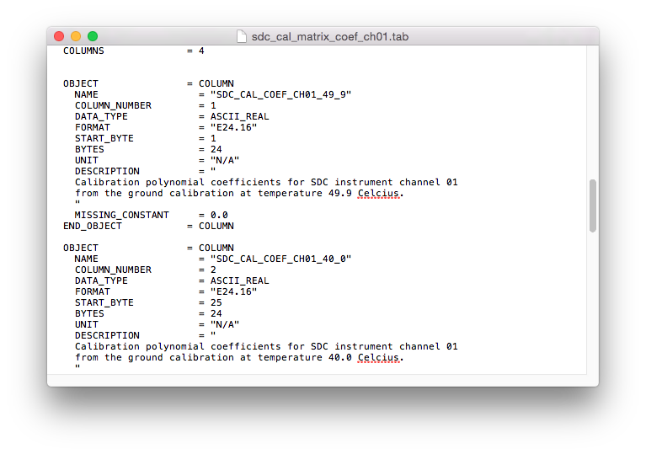
calib/calinfo.txt
- Calib[r]ation spelled wrong in the N.B. note
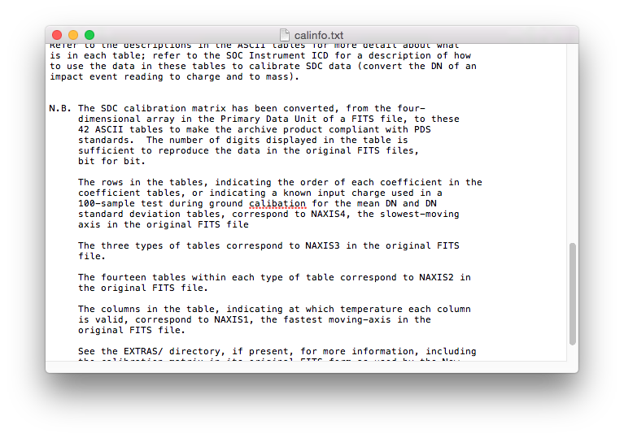

There is a statement (in catalog/sdc.cat) that they haven’t detected particles over 3µm since early 2014.
1) How significant is this? Does it point to a larger systematic problem? Is it becoming less sensitive?
2) This note is weird for this documentation because generally particles are referred to by their charge and mass, not by size, and I don’t think the equation for the conversion is anywhere in the documentation.

Data:
- Played with data with PDSREAD
  - Looked at some data, seems ok – data, dates correspond in 2 and 3

- Question about velocity used:
In data/…sci.lbl files, the “IMP_VEL” parameter is given as
IMP_VEL = 1E-3 x SQRT(G x Msun x (1-beta) / R)

where
G = Gravitational constant = 6.77384E-11
Msun = Mass of the Sun, kg
beta = 0 = correction for solar pressure
R = Heliocentric distance, m

Units consistent with G (m**3 kg**-1 s**-2)

- Why not provide the value of Msun?
- The sdc_ssr.pdf states (p.5) that the value used for the velocity calculation for the grain mass (“MASS” parameter) is the s/c velocity
- Working backwards from the IMP_VEL values, these don’t correspond to the s/c distance
- What are these values? Are they used to get the MASS parameter?

  - Generally unclear how the housekeeping data is used for calibration (I probably missed a doc that described this?)
  - For instance, some HK data includes “Conversion: polynomial coefficients:” – how is this used?
  - HK data from other instruments are included (but not used)?

