New Horizon “map projected” PDS3 Review
-Trent Hare, thare@usgs.gov
Must haves (liens) will be highlighted

NH-P/PSA-LEISA/MVIC-5-COMP-V1.0
I have always found it odd in many PDS3 archives that all references to files in the docs (e.g. aareadme.txt, voldesc.cat, indxinfo.txt , chksum.tab, etc.) point to uppercase filenames but all the files in the tar and website are lowercase. Nothing to do here -- just seems a little problematic for automating from catalog files to find the actual files. I am also missing nice easy to use Jpeg browse images, obviously not for every band but maybe a single band per image (excluding the geometry files).
- aareadme.txt
  - Line 107, description misspelled
- voldec.cat
  - Line 51-54, odd to see “\n” in the text
- dataset.cat
  - Line 49, is mosaiced really spelled mosaicked
  - Spell out MET, CCD first occurrence in text file.
  - Reference for FITS would be nice
  - The first reference to ISIS should be spelled out – only second occurrence is. Good to use ISIS3 for acronym. Reference to ISIS3 would be nice (there is one in the LORRI ref.cat file Keszthelyi…)
  - -3.4028235e-38 defined as NoDATA in the file but not in label
  - Line 293, “cube fits files” should capitalize FITS
  - Line 275: Spice should be spelled out, first use, and capitalized
  - For absorp files the NoDATA is set to -99. It would be nice to use the same “NoDATA” across data sets. “mosaic/” files use a different NoDATA.
  - Line 317: not required but write out CH4, N2, … (or add reference)
  - Line 377: spell out S/N
  - Line 415: “one spectel” – misspelled?
- dataset_projection.cat
  - Many files that are global and have a “geometry” do not use a FITS or PDS map projection in their labels. Without this map projection described in the label, the usability of the files are much less usable in many existing mapping applications.
  - I do not think the conversion from Lat/Lon to Line/Sample is correct. The LOLA team uses the same projection and have a really good section with example. This whole part can probably be taken from: http://pds-geosciences.wustl.edu/lro/lro-l-lola-3-rdr-v1/lrolol_1xxx/catalog/dsmap.cat
Also the values the LOLA team have calculated have been checked and rechecked by several people (because there was/is a problem with the MOLA archive).

- leisa.cat
  - For the “required” reading, it would be nice if a link to arxiv.org PDF was provided as the Space Science link (from the DOI) states the journal article must be purchased.
  - Line 82: spell out SOC, first use
  - Line 103, 144, 171... : use PDS reference style (or both)
  - Line 150: spell out JDSU
  - Line 439, “The details of the DARK_SKY compression algorithm parameters will not be covered here” - maybe a reference is needed then.
- mvic.cat
  - Line 46, Integration misspelled
  - Line 236; use PDS reference style (or both)
- ref.cat
  - many references use “et al.” all authors should be listed
  - Some references missing doi.
  - Pick first names or abbreviations – there is a mix.
  - Any chance of http links? (with last access dates)
  - MCEWEN1991 – no title or doi
  - Most refs don’t use “pp.” – some do
  - FOUNTAINETAL2008 is locked down (cost $). Can this or any other locked articles be pushed to arxiv like REUTERETAL2008
DATA
- absorp/
  - Not much of a FITS label, why even have one? There is no description or definition of NoDATA or WCS defined (e.g. CAR projection). Might as well be a raw binary (see fig. 1).
  - So using a geometry file for a global map projected file is not very “good” form for map projected data. Simply adding in an “easy” map projection section in the PDS3 label, will make these data sets so much more useful in mapping applications.
  - Ds9 and AstroPy read in the FITS image flipped differently – Apparently, it is an AstroPy thing, which seems odd being both FITS readers. Nothing to do here – just odd. Is there supposed to be something in the FITS label to tell AstroPy to read “UP” – just curious?
  - Actually, the images are flipped from geometry. Looking into the PDS labels, the images have LINE_DISPLAY_DIRECTION = “UP” and the geometry file does not. This makes sense, but I think will make for a very confusing load with the images “UP” and the geometry set using the default “DOWN”. I would much rather the images be flipped to match the “driver” geometry files (or vice versa).
  - All PDS labels are extremely basic. There should be fuller labels. For example, as stated above I strongly encourage you to add in a map projection section (be happy to help).
  - In addition, keywords like “MISSING” or “MISSING_CONSTANT” should be added to define the NoDATA value of -99. In most of map projected 32bit PDS3 data sets the NoData is generally -3.4028235e-38 (as in “mosaic/” files here). For QUBE, I believe it is CORE_NULL. See this page for more info and an example.
  - See figure 1 (below) for some extraneous pixels which should be NoDATA.
- color/
  - Similar comments on “absorb/” but the images appear to have bad labels (see 5-8).
  - Major difference that these appear to not be in a true map projection. Thus, the geometry file is more appropriate here. It also looks like the geometry is not flipped as compared to “absorb/”.
  - I like that these labels have several more keywords like NULL:
    - CORE_BASE = 0.0
    - CORE_MULTIPLIER = 1.0
    - CORE_NAME = "RAW DATA NUMBER"
    - CORE_UNIT = "DIMENSIONLESS"
    - CORE_NULL = 16#FF7FFFFB#
  - Although the files are still missing wavelength keywords (see “mosaic/”)
    - FILTER_NAME = ("CH4", "NIR", "RED", "BLUE")
    - CENTER_FILTER_WAVELENGTH = (895 <nm>, 870 <nm>,
    - 625 <nm>, 475 <nm>)
    - BANDWIDTH = (40 <nm>, 180 <nm>,
    - 150 <nm>, 150 <nm>)
  - But NASAView has a label issue (even with PDS3 data).
    - 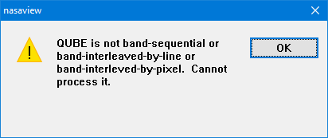
    - To fix this error I had to update two keywords to
    - From: AXIS_NAME = “(SAMPLE, LINE, BAND)“
    - To: AXIS_NAME = (SAMPLE, LINE, BAND)
    - Added: BAND_BIN_UNIT = "N/A"
  - To get ISIS3 to convert I had to update AXIS_NAME (as above) and change all CORE_* from “N/A” to values or “**ERROR** Failed to convert string [N/A] to a double.”
  - To get GDAL PDS3 reader to work I had to update:
    - From:
    - ^QUBE = ("0299026199_CHARON_CUBE.FIT"
    - OBJECT = QUBE
    - to:
    - ^SPECTRAL_QUBE = ("0299026199_CHARON_CUBE.FIT"
    - OBJECT = SPECTRAL_QUBE
    - This seems a GDAL quirk where it was only coded for SPECTRAL_QUBE not QUBE
  - “PlanetaryImage” Python (written for rover data) - only accepts ^IMAGE but too many other label items it is not ready for to even get it to read these files.
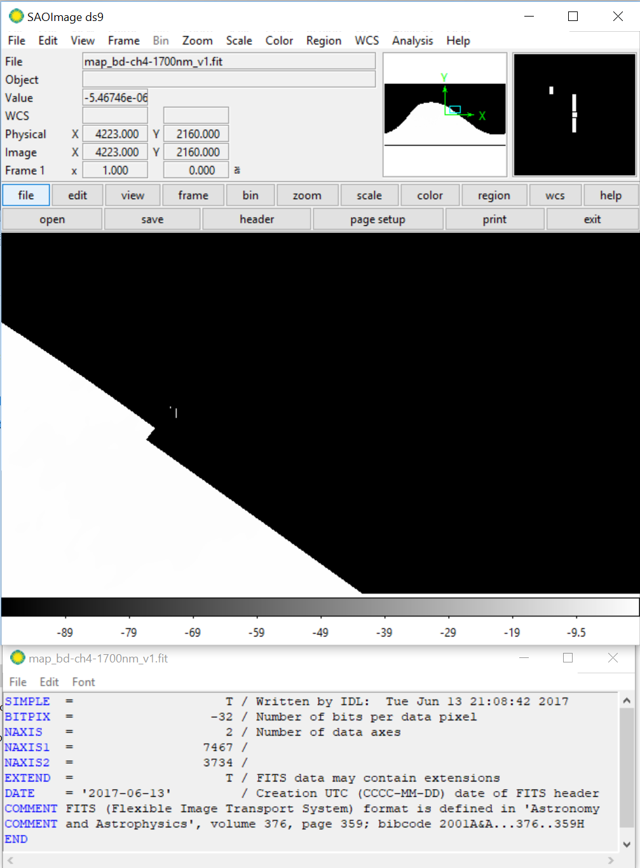
Figure 1. absorp/map_bd_ch4-1700nm_v1.fit showing odd pixels values around 4223, 2158 (from DS9 so perhaps up-side-down).
- mosaic/
  - labels are nicely verbose including a map projection section although there are some registration issues.
  - Files missing some nice keywords for IMAGE section
    - MAXIMUM = XXXX
    - MINIMUM = YYYY
    - UNIT = ZZZZ
  - File cpmap_cyl_k3201.img has a wrong value. The map is 180 degrees shifted within its Cartesian plane (the map projection). The correct value should be:
    - SAMPLE_PROJECTION_OFFSET = 1903.5 <pixel>
    - Map is from -180 to 180 with a center of zero (that looks good).
  - File pmap_cyl_k3201.img appears to have correct SAMPLE/LINE OFFSETs but it is oddly map is defined from -10.00 degrees to 360.0 degrees. The center is set correctly at 180 degrees but there is really an unneeded 10 degrees in Longitude.

NH-P/PSA-LORRI/MVIC-5-GEOMAPS-V1.0
Not sure why this archive is called “Geology”. There are no geologic maps even though the file ref.cat have tons of geologic maps referenced. Seems to be strictly geophysical data.
- File dataset.cat
  - “32bit pixel values were stretch to 8bit”. No the file are 32bit. But I would almost rather see the 8bit version here (or both). Documenting the stretch pairs is good.
  - Where are references for the creation of the DTMs and mosaics? I think Schenk’s papers are supposed to be here. (SCHENKETAL2017A, 2017B). I hope that we can read these since they have been submitted. I do have some concerns, which the paper should help with. For example, the DTM and mosaic are the same resolution, which implies this must be photoclinometry. Overall, for such an apparent complicated mix of data types, there really is not much detail for the overall process or resulting uncertainty.
  - Not sure I get the “DTM Processing Parameters” section, It read almost exactly like the mosaic processing parameters section. If the same images and process were used just state that for this section.
  - Not sure what “vertical resolutions as high as 100 m” means? Perhaps a little more there (or reference a paper). Is that the precision? If so, then there is no need for a floating point DTM.
Same “ref.cat” issues as above (et al., first names, doi…)
- albedo/
- These are 8bit files, you would think these would be 32bit or if intended to be 8bit provide the stretched values (or offset, multiplier).
- Albedo FITS files appear to open in DS9 no problem. Upside-down in AstroPy (as stated above – not a problem unless something is missing from FITS label.
- Albedo PDS labels are extremely basic. Labels should be more complete. I strongly encourage the team to add in a map projection section (be happy to help).
- Files missing some nice keywords for IMAGE section
  - MAXIMUM = XXXX
  - MINIMUM = YYYY
  - UNIT = ZZZZ
  - In addition, a keyword like “MISSING” or “MISSING_CONSTANT” should be added to define the NoDATA value (here 0). For QUBE, I believe it is CORE_NULL. See this page for more info and an example.
- For derived data, it is not good to include scale bars in the image. This makes it hard to display on map. Scale bars are perfect for figures say in the browse or “extras” but not for data files.
- I cannot figure it out but it seems there might be a label issue. Did anyone else see a quirk in the existing label parameters? Please check in a couple PDS3 readers
- dtm/
  - Files missing some nice keywords for IMAGE section
    - MAXIMUM = XXXX
    - MINIMUM = YYYY
    - UNIT = KILOMETER
  - File nh_charon_dtm.img (Minimum=-14.133, Maximum=6.911, Mean=-0.484, StdDev=2.677) looks good although there might be 1.5 pixel offset in the Line/Sample OFFSETs. I believe them to be:
    - LINE_PROJECTION_OFFSET = 3173 <pixel>
    - SAMPLE_PROJECTION_OFFSET = 6346 <pixel>
  - File nh_pluto_dtm.img (Minimum=-4.101, Maximum=6.491, Mean=0.442, StdDev=1.109) looks good although there might be 1 pixel offset in the Line/Sample OFFSETs. I believe them to be:
    - LINE_PROJECTION_OFFSET = 6221.5 <pixel>
    - SAMPLE_PROJECTION_OFFSET = 12443.5 <pixel>
  - I wonder if like LOLA, the image should be 16bit Signed Integer (times by a 1000 and round/truncate). I would be surprised if the precision in the height values are better than a meter. If so, then an additional scalar could be applied (also like LOLA. LOLA was deemed only good to about 0.5 meters vertically).
- mosaic/
  - Same offset issues potentially here. Same values above should also work.
  - A simple optimized 8bit version of the mosaic would be nice for users and as stated in the dataset.cat file (in archive or extras).
  - nh_charon_mosaic.img - Minimum=-0.070, Maximum=1.366, Mean=0.255, StdDev=0.067
  - nh_pluto_mosaic.img (stats are painful since apparently there are multiple NoDATA values – perhaps a Low Saturated value. For archival I prefer to see all NoData type values pushed to a single value). This will not be a problem with an 8bit version.

