New Horizons ‘Pluto Encounter Composition Maps’ PDS3 Review
Glen Cushing, gcushing@usgs.gov

NH-P_PSA-LEISA_MVIC-5-COMP-V1.0:

aareadme.txt:

line 33: 'that' -- should be 'which'

line 60: is DOCUMENT/ in a higher level directory?

line 61-63 -- can a specific location be provided?

line 107 -- 'Description' misspelled

voldesc.cat:

Lines 51-53: End-of-line (/n) symbols seem to be accidently inserted with SWRI's street address.

catalog/

catinfo.txt:

line 15: The word 'Composition' is in the wrong spot.

line 76: 'low-light level' should be 'low-light-level'

line 125: Needs period at end of paragraph.

dataset.cat:

lines 106-169: This section (‘/color’) describes how the data were generated, but is missing a basic description of its contents, and lacks an opening like ‘This dataset contains….’ (see the opening paragraph of the next section ‘/spec’ for a good example…)

line 149: Add closing parenthesis at end of equation.

line 183: 'this' should be 'these' (plural)

line 479: just a reminder to set date

leisa.cat:

line 92: In Scientific Objectives, only the 2nd of 4 objectives is closed with a period.

line 103: should end with a period to be consistent with other citations.

line 113: f8.7beam should be f8.7 beam.

line 114: push-broom

line 232: algorithms should be algorithm

line 391 and 415: For consistency, remove period at end of line

mvic.cat:

line 42: Charge-Coupled Device should be Charge-Coupled-Device

line 46: integration misspelled

line 48: which --> where

line 78-79: awkward text arrangement

line 270: Sentence should be re-worded

nh.cat:

line 81: while technically acceptable, ‘kmph’ is unusual and a little distracting ... km/h?

nhsc.cat:

line 76: 'low-light level' should be 'low-light-level'

line 125: Needs period at end of paragraph.

data/

data/absorb/

--The .fit files process correctly in ISIS3. Not sure why ‘BITPIX = -32’ is negative.

--the label for the geometry file must formally define and describe each band - individually.

--The .fits labels are very sparse as well.

When I open the geometry file alongside the images, I’m not convinced the geometry and image are oriented correctly with each other—or how I would verify. Why not map-project?

data/color/

--Filenames for Nix and Hydra images could be improved.

--Nix and Hydra will not process in ISIS3, but will in IDL.

--Instead of a primary file with fits extensions, the Nix and Hydra files will open only as extensions (won’t simply open as a fits file unless I declare it as an extension).

--the labels for these multi-band files must formally define and describe each band - individually.

--Very sparse labels for the 4-band MVIC images—insufficient. What are the 4 bands?? The image label describes the 5 bands in its associated geometry file, but doesn’t describe its own contents…. Labels could be modeled after the labels for Nix and Hydra in this directory.

--The Nix and Hydra images in this directory have the only ‘real’ fits headers I’ve seen.

The Nix and Hydra will not process in ISIS3:

cube_n_color_best.fit
cube_n_color_2.fit
cube_h_color_best.fit

Each returns the following error:

**USER ERROR** The FITS file does not contain a section header that looks like it describes an image.

--ISIS3 is picky, but there’s probably something very simple that can be changed in the headers….

These also will not process in ISIS3, but for a different reason…

mvic_0298824437_0x545_geom_pl.fit
mvic_0298853042_0x545_geom_pl.fit
mvic_0298853212_0x536_geom_pl.fit
mvic_0298891582_0x545_geom_pl.fit
mvic_0298939122_0x545_geom_pl.fit
mvic_0298939122_0x545_sci_pl.fit
mvic_0298939292_0x545_geom_pl.fit
mvic_0298939292_0x545_sci_pl.fit
mvic_0299176432_0x536_geom_ch.fit

Here, the error is:

terminate called after throwing an instance of 'std::bad_alloc'
what(): std::bad_alloc
badscript: line 7: 1516 Aborted

**I have not found the difference between these files and the ones that process properly in ISIS3. Some files in the /spec directory fail for the same reason, but there is no obvious correlation among the failing images. Again, these all open without issue in IDL.

data/spec/

--for the Nix, Hydra and Kerberos files with fits extensions—since each extension carries its own header information -- why not name each extension in its own header (e.g., wavelength, flat field, etc.) like with the Nix and Hydra products in /color? Also, why not list the extensions in the primary header?

--the labels for the geometry files should formally define and describe each band – individually – listing them in the overall description is insufficient.

In all files I’ve examined in /spec, channels 199-207 (last channel of low-res + 1st 8 channels of hi-res) do not contain data.

Headers in the wavelength .fit files declare EXTEND = T, but no extension can be called.

Off-body pixels are NAN in wavelength files, but -3.40282e+38 in the cube and geometry files.
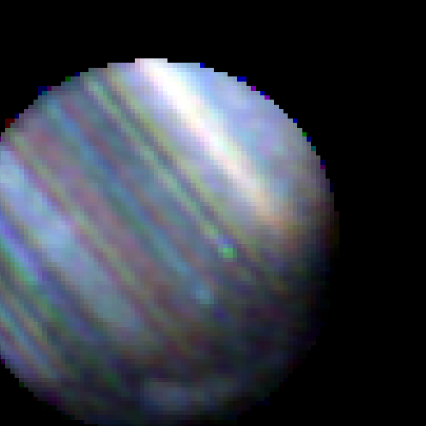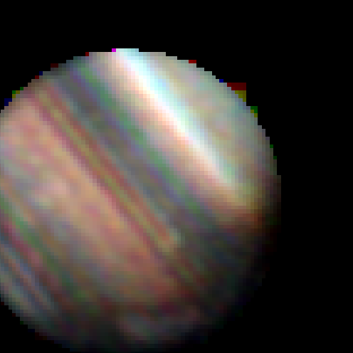0299105209_pluto_cube.fit - Left image looks normal (bands [210, 211, 212]) while for some reason the center (RGB=bands[208, 209, 210]) and right (wavelength band 208) images have big spikey artifacts – only for a small number of wavelengths does this occur, and not in all image sets…

Some of the .fit files do not process in ISIS3, but ALL of them process properly in IDL (which is much more forgiving).

The following files will not process in ISIS3:

0299026199_charon_geometry.fit
0299064869_charon_cube.fit
0299064869_pluto_cube.fit
0299064869_pluto_geometry.fit
0299144829_pluto_cube.fit
0299144829_pluto_geometry.fit
0299146219_charon_geometry.fit
0299176809_pluto_geometry.fit

Error:
terminate called after throwing an instance of 'std::bad_alloc'
what(): std::bad_alloc
badscript: line 13: 30296 Aborted

These files gave a different error:

0299176809_pluto_cube.fit
0299176809_pluto_wavelengths.fit

3�?Q�?��?U�?���>�>F>���?] is invalid. Keyword name cannot contain whitespace.

index/

index.lbl:

lines 127 and 137 say the same thing -- suggest distinguishing them by specifying abbreviation or full-name.

