PDS Lucy L’TES Archive Review
Jean-Philippe Combe, May 30, 2023
Contents
1 Introduction 1
2 Data 1
2.1 data_cruise1_calibrated 2
2.2 data_cruise1_raw 3
3 Document : document\22668.07-LTES-SIS-01 R0 C0 draft_VEH.docx 3

Introduction
The objective is to review L’TES data samples which show the pipeline performance. The sample datasets are small and mainly require checking the metadata and documentation. The Lucy archiving team warned us that the L'TES data may not provide the right values, so the values should not be a concern.
We open, read and visualize the labels and data with the PDS4Viewer.

The archive currently consists of 9 files in 3 directories
data_cruise1_calibrated
lte_0874281421_sci_1.xml
tes_0719078834_00000_sci_01.hdf
tes_0719078834_00000_sci_01.xml
tes_0719078834_00000_sci_address.txt

data_cruise1_raw
tes_0719077727_02063_address.txt
tes_0719077727_02063_eng_01.hdf
tes_0719077727_02063_eng_01.xml

document
22668.07-LTES-SIS-01 R0 C0 draft_VEH.docx
ltes_document.xml

Data
PDS Labels and Meta Data
• Are the descriptions and scientific content contained inside the PDS labels sufficient to understand their corresponding data products?
Prior to reviewing, we were notified of the following issues with LTES Labels
Raw
1. Spectral Characteristics all need to be rectified. The current values are all based on OTES rather than LTES. We will certainly update these.
2. Arrays need a units check with the science team.
Calibrated
1. The .hdf data file is not perfectly formatted for PDS4 at this point. We have some work to do to remove chunking and compression. The label mostly describes the data, but it is more the idea of how we will do this rather than a valid product. The PDS4 viewer can be used to see the general idea of how the product will look, but tables/images will not open.
• Is all significant meta data included directly in the PDS labels?
- Yes, except TBR occurrences
• Do the labels provide all essential description of data values directly in the label, instead of deferring them to external references or documentation?
- Yes, except TBR occurrences
• Can the data be read programmatically using only the information contained in the PDS labels?
- Yes, as illustrated by screen captures of the PDS4Viewer below.
Data
• Does the data look physically reasonable when examining it by eye or via a display tool?
- Yes
• When displaying the data as plots or images, are there any unexpected deviations?
- None noted
• Formulate a scientific inquiry and attempt to use the data to answer the inquiry.
• If reviewing both raw and calibrated data, attempt to calibrate a raw data file.
- N/A, as calibrated data are not provided and “the LTES data calibration flow and algorithms are documented in the LTES Instrument Paper (TBD)”.

data_cruise1_calibrated
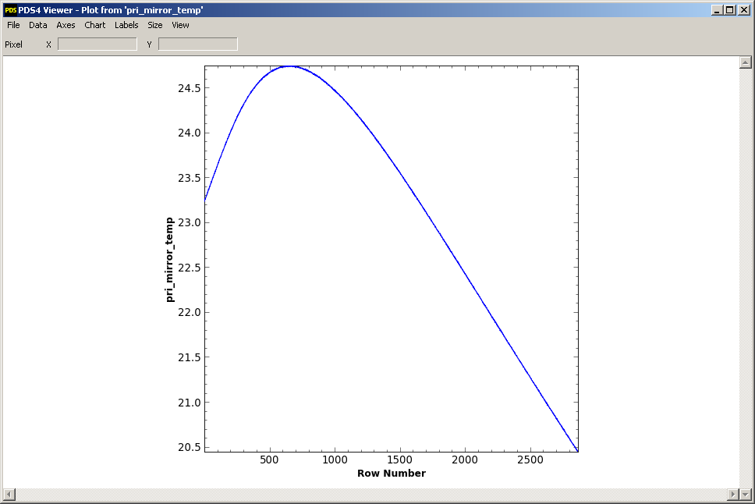
Figure 1: Example of engineering data plot (primary mirror temperature).

data_cruise1_raw
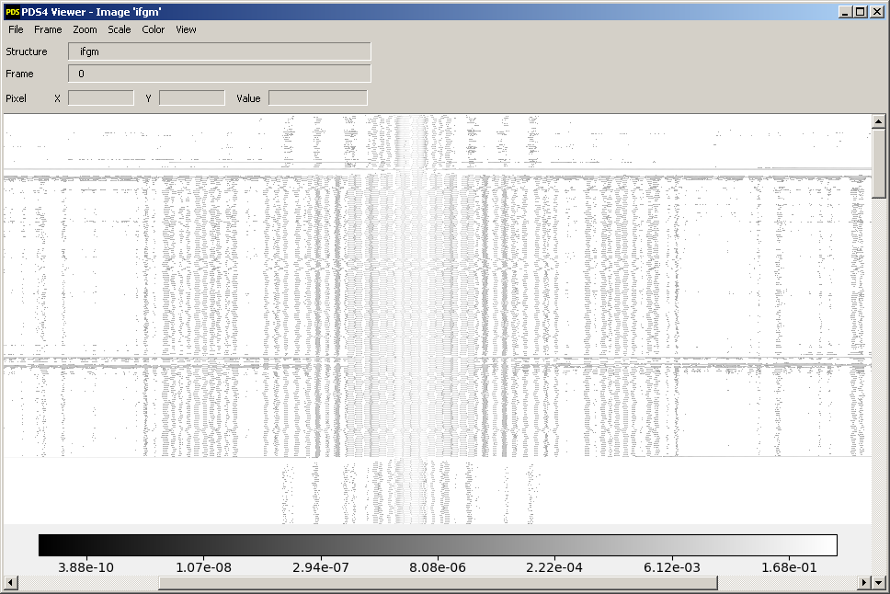
Figure 2: Example of image display in PDS4Viewer: Interferogram array (ifgm).
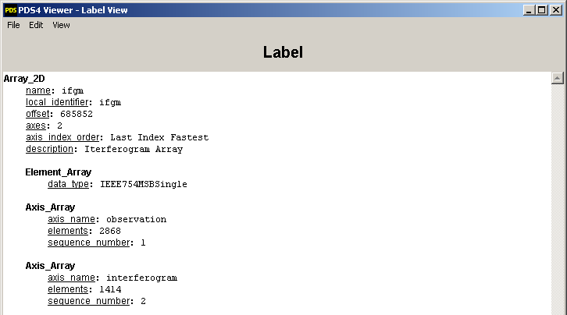
Figure 3: Example of label display in PDS4Viewer: Interferogram array (ifgm).

Document : document\22668.07-LTES-SIS-01 R0 C0 draft_VEH.docx

• Does the dataset contain all documentation needed to use and understand its data without prior knowledge?
Figure 2 1 (LTES scan of a Trojan asteroid) illustrates the projected LTES instantaneous field of view (IFOV) and observation path on a schematic representation of an asteroid as a sphere.
- Given the irregular shapes of the asteroids, how can we be sure that the IFOV always intersects with the surface and does not include space, especially for observations of the non-illuminated side?
- Are the conditions for a minimum of 4 observations at different times of day always met, regardless of the shape of the asteroid?
- How 1/8 of the Trojan's diameter is defined on a body that has an irregular shape?
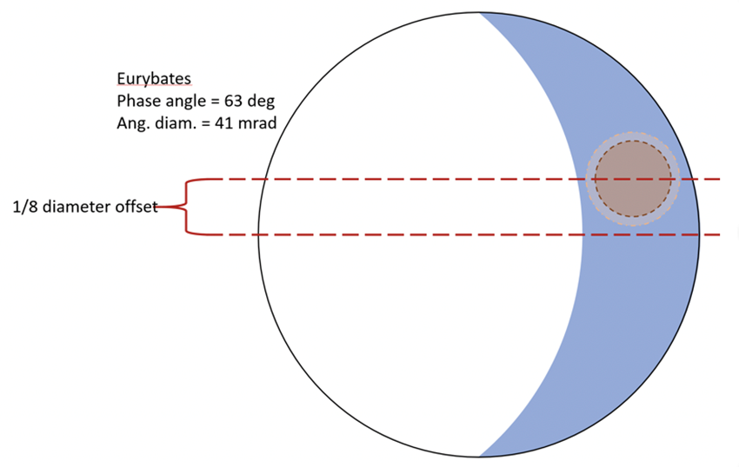
• Is the provided documentation well organized, clear and self-consistent?
- What does IPP stand for?
- P. 10/33 (page 6): “cal files” should be spelled “calibrated files”.
• Can the dataset be understood without any external documentation it references, or should the information in said external references be incorporated into the dataset?
- Observation ID = ObsID is defined on P.12/33, whereas its first occurrence is on P.10/33
- PPS is not clearly defined (Number of tic (PPS) pulses received.). Does PPS stand for Pulses Per Second?
• If reviewing calibrated data, does the documentation fully explain the calibration process and contain all necessary parameters needed to repeat it?
- N/A as only the engineering data is readable.

