Documentation
- Does the dataset contain all documentation needed to use and understand its data without prior knowledge?
  - I believe so. There are some places where the descriptions will need to be improved when calibrated and geometry data becomes available.
    - On page 7, highlight that 6.5 mrad is the FWHM.
    - On page 7, Vicky has a comment about the data having a minimum of 4 locations across the asteroid. Perhaps clarify.
    - Page 8, I find fig2-1 to be a bit confusing. It’s the pointing uncertainty always 1/8 of the asteroid’s diameter? Won’t this vary with distance and size? Alo- is the scan direction going to towards the left?
    - Section 2.3.1 is not very helpful as currently written.
    - Table 2-3 is missing where ENG data falls (or at least its not clear).
    - Table 2-5 must be TBR as there are no volume data shown.
    - The table on Page 25 is either a duplicate or one table is uncalibrated and the other is ENG. I can’t tell.
- Is the provided documentation well organized, clear and self-consistent?
  - Generally, but there are many places labeled TBR.
- Can the dataset be understood without any external documentation it references, or should the information in said external references be incorporated into the dataset?
  - I think so, at least for the engineering data. Once again, several places are still labeled TBR.
- If reviewing calibrated data, does the documentation fully explain the calibration process and contain all necessary parameters needed to repeat it?
  - N/A as only the engineering data is readable.

PDS Labels and Meta Data
- Are the descriptions and scientific content contained inside the PDS labels sufficient to understand their corresponding data products?
  - “Iterferogram” is misspelled in labels:description, but not in the ifgm axis_name labels.
- Is all significant meta data included directly in the PDS labels?
  - As far as I can tell using the PDS4_Viewer.
- Do the labels provide all essential description of data values directly in the label, instead of deferring them to external references or documentation?
  - Generally
  - Table 3-1 has a label for cmd_fc_echo and cmd_seq_echo but in the meta data “cmd” is replaced with “cal”
  - Table 3-1 index starts at 1 but the PDS4 Label has it starting at 0.
- Can the data be read programmatically using only the information contained in the PDS labels?
  - For the ENG data – yes. Some of the science data labels are already valid using the PDS4 viewer.

Data
- Does the data look physically reasonable when examining it by eye or via a display tool?
  - Yes
- When displaying the data as plots or images, are there any unexpected deviations?
  - None that I noticed.
- Formulate a scientific inquiry and attempt to use the data to answer the inquiry.
  - Figure 1 (below) shows an interferogram and its FFT inversion. It does resemble what I would expect for a thermal spectrum. It generally looks like a blackbody curve with non-uniform emissivity.
- If reviewing both raw and calibrated data, attempt to calibrate a raw data file.
  - N/A
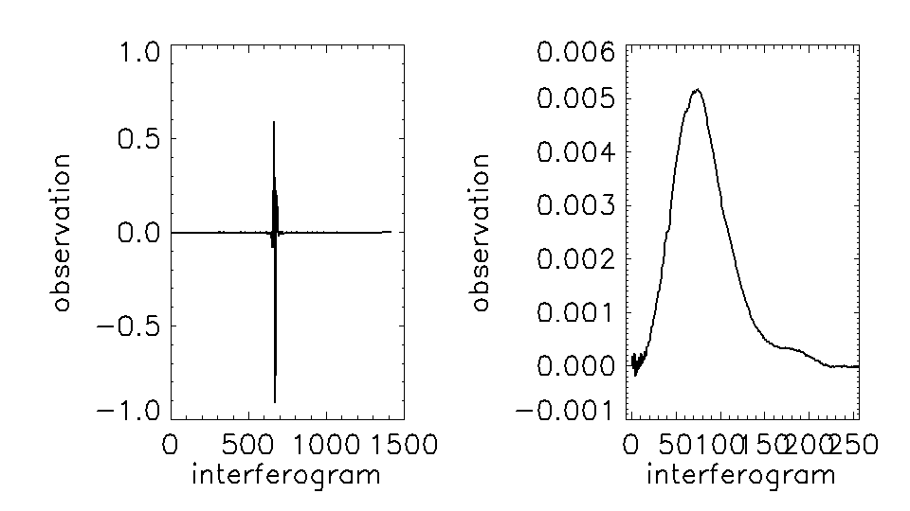
Figure 1: (Left) an interferogram from the PDS ENG data file. (right) The DFT of the interferogram.

