The purpose of this document is to convey the results of my SIS and data review. I used IDL to conduct my analysis. The read_pds.pro routine was essential for this analysis and worked perfectly except for a minor glitch noted below. The meta-data checks were done during the data analysis using IDL and a final check was completed using the PDS4_VIEWER.
1. Overview review of documentation
- SIS
  - The SIS contains data product tables for the uncalibrated and the calibrated data but not for the engineering data. This was somewhat problematic as the engineering data was provided for the pipeline review, but not the raw data. I was able to query the engineering files to find the locations of the needed calibration coefficients.
- Christensen et al. paper
  - Page 5: “TIM’ probably should be “TIU.”
  - Page 18: Is this figure actually 5a?
  - Page 19: Figure 5 has labeled the top of the figure with the wavelength values that correspond to the wavenumbers on the lower x-axis. The upper x-axis is useful, but the axis label is missing. This also applies to Figs 10a, 11, 12, 14 and 15.
- Overall, the documentation provided most of the essential descriptions to “validate” the calibration pipeline. The exception may be wavenumber calculation and calibration. The Christensen et al. paper discusses wavenumber calibration and stability in section 6.5, specifying that the laser wavelength is 0.851 um, independent of temperature. Unless I missed it, the SIS does not discuss how the wavenumber range used in the SCI data products was determined.
2. In-Depth Review: Uncalibrated Data
The main issue with the ENG XML files is that the dimensions for the IFGM are switched. There should be 1414 samples for each interferogram. The number of observations will vary. Here is an example where there were 40 observations. I have highlighted the values that were switched.

<Array_2D_Spectrum>
<name>ifgm</name>
<local_identifier>ifgm</local_identifier>
<offset unit="byte">35285</offset>
<axes>2</axes>
<axis_index_order>Last Index Fastest</axis_index_order>
<description>Interferogram</description>
<Element_Array>
<data_type>IEEE754MSBSingle</data_type>
</Element_Array>
<Axis_Array>
<axis_name>observation</axis_name>
<elements>1414</elements>
<sequence_number>1</sequence_number>
</Axis_Array>
<Axis_Array>
<axis_name>sample</axis_name>
<elements>40</elements>
<sequence_number>2</sequence_number>
</Axis_Array>
</Array_2D_Spectrum>

The data is stored properly so I was able to “reformat" the interferograms as shown in the attached figure. The interferogram in Figure 1 (panel D) looks like what I would expect.

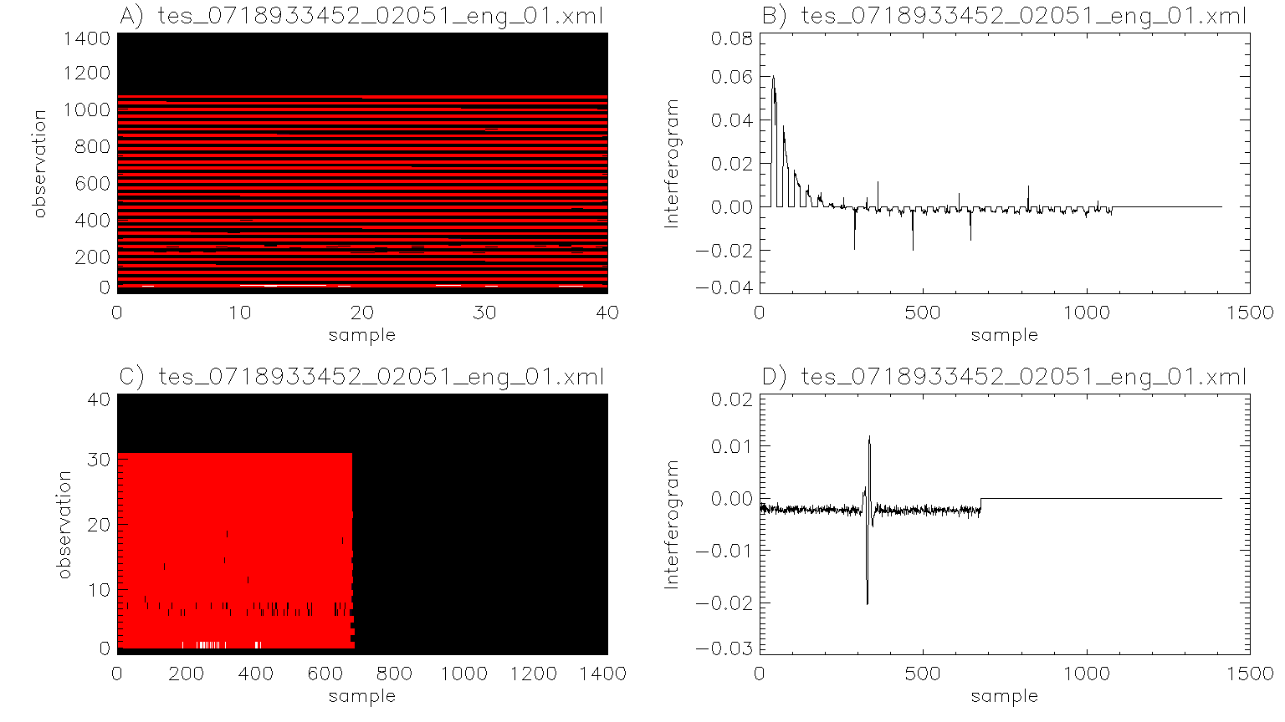
Figure 1: Interferogram issues: The ENG XML files have the dimensions for the IFGM switched. There should be 1414 samples for the interferogram. The number of observations will vary. Here is an example where there were 40 observations. 4 Panel display of (A) the interferogram as extracted from the PDS4 ENG file with (B) the extracted interferogram for the center observation and (C) the reformatted interferogram with (D) extracted center observation interferogram.
3. In-Depth Review: Calibrated Data (focus on lunar observations)
This section mostly examines the calibrated lunar observations. The calibrated lunar observations appear to be fine. Subpixel missing of multiple temperatures within the FOV is obvious as shown in Fig 2-4. The brightness_temp arrays were zero’d out.
Emission angle fields were filled in and were obviously for the Moon. Observations of the Earth had emission angles coded 9999. Obviously, this will get tricky when a calibrated SCI file contains multiple objects.

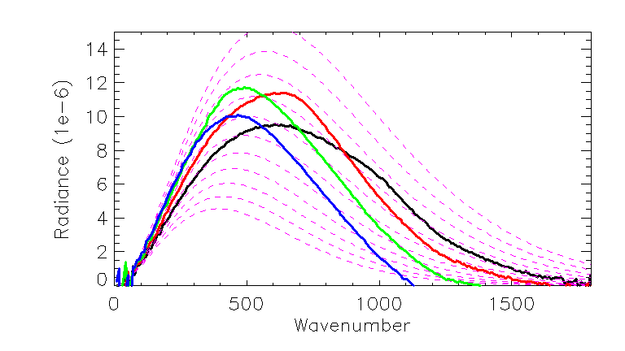
Figure 2: Calibrated observations of the Moon. Black, red, green, and blue lines are consecutive spectra. The dashed purple lines are for blackbody temperatures ranging from 200K to 300K in 10K increments.

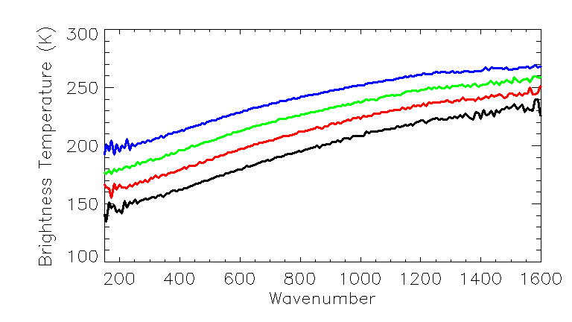
Figure 3: Calibrated observations converted to brightness temperature by me. Black, red, green, and blue lines are consecutive spectra. The spectral slope is indicative of subpixel mixing of different temperatures. LTES must be scanning towards a hotter region.

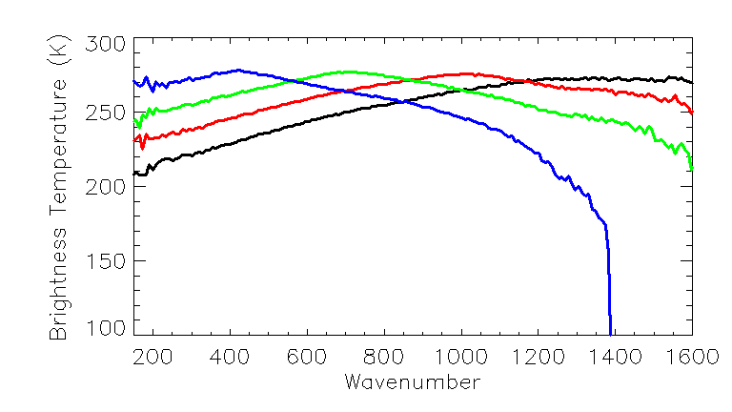
Figure 4: Calibrated observations converted to brightness temperature by me. Black, red, green, and blue lines are consecutive spectra that were immediately acquired after Fig 2. I suspect that the sudden drop off in brightness temperature for the blue line may be due to LTES scanning off the edge of the moon.
4. In-Depth Review: Calibration Pipeline (Earth Observations)
This section describes my attempt to calibrate the provided engineering data to match the LTES calibrated data provided in the SCI data file. I was able to use SCLK to match raw and calibrated observations between the SCI and the ENG data products.
The first step was to convert the IFGM to a “voltage” by taking the DFT of the IFGM. “Trimming” the IFGM size determines the wavenumber range. I also needed to remove spikes in the IFGM prior to taking the DFT, which is described in the SIS.
The next steps where to identify appropriate space-looks and calibration looks. I used the calibration_flag_status to identify locations of calibration-looks. The SIS describes the process to use multiple calibration-looks and then interpolate to account for instrumental drift. I did not do this and only used a single calibration look. I identified a space-look based on calrad channel 50 values. I typically use the emission_angle to determine space-looks but that was not workable as the emission angles were determined for the Moon, not for the Earth. As with the calibration-look, I only used one.
Once the space-look and calibration-look observations were identified, the IFGMs were converted to “voltage” in the same manner as the IFGM for the scene.
Table 2-3 and the equation above it were essential for validating the calibration pipeline. There was not an ENG equivalent to Table 3-2 or Table 3-4, so I used the PDS4_viewer to identify where to extract the varies temperatures for the mirrors and calibration source. Once temperatures were extracted, I converted them to Kelvin and then using the wavenumbers from the SCI data file, I generated the appropriate blackbody curves. Using the equation located above table 2-3 (equation not numbered), I generated my own calibrated spectrum, which is shown in Fig. 5. Small variations between the LTES calibration and my calibration are expected as I only used one space look and one calibration look, instead of the multiple looks with interpolation that the LTES describes in the SIS. The IFGM was trimmed at index 680 before doing the DFT. The fringe count from the ENG data is 680 and the wavenumber interval is consistent with a laser wavelength of 851nm.
The brightness_temp array was not populated, but the kinetic temperature for the scene is likely ~263K.
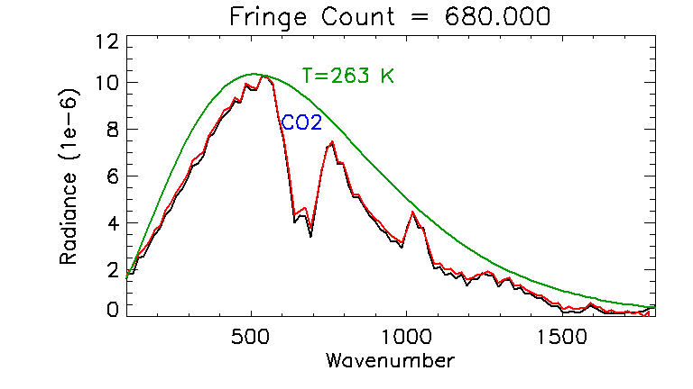
Figure 5: Comparison of the LTES provided calibration spectrum of Earth (black) and my attempt at calibration the corresponding engineering IFGM (red). The brightness_temp array was all zeros, but the green line shows a blackbody curve for T=263K. The strong CO2 absorption band is identified in blue. Small variations between the LTES calibration and my calibration are expected as I only used one space look and one calibration look, instead of the multiple looks with interpolation that the LTES describes in the SIS. The IFGM was trimmed at index 680 consistent with the fringe count.
5. Meta Data
Meta data was validated throughout the analysis process using IDL. The PDS4_VIEWER was essential for locating the mirror and calibration temperatures. I have an older PDS4_viewer, so that may be the issue. I was not able to access the “stream_text.” My IDL routines for reading PDS4 files are also old, but read_pds.pro did not recognize “stream_text” either. While I was able to validate the calibration pipeline, it is obvious from the SIS that the stream_text contains important meta data. Perhaps PDS can address this in the future.
6. Review reports and conclusion
[Major] Correct the number of elements for the observation and sample sizes for IFGM in the XML file.
<Array_2D_Spectrum>
<name>ifgm</name>
<local_identifier>ifgm</local_identifier>
<offset unit="byte">35285</offset>
<axes>2</axes>
<axis_index_order>Last Index Fastest</axis_index_order>
<description>Interferogram</description>
<Element_Array>
<data_type>IEEE754MSBSingle</data_type>
</Element_Array>
<Axis_Array>
<axis_name>observation</axis_name>
<elements>1414</elements>
<sequence_number>1</sequence_number>
</Axis_Array>
<Axis_Array>
<axis_name>sample</axis_name>
<elements>40</elements>
<sequence_number>2</sequence_number>
</Axis_Array>
</Array_2D_Spectrum>
[Major] The engineering data products table should be added to the SIS.
Please add the ENG data product equivalent to Table 3-2 or Table 3-4. Not having that table available means one must use the XML files to identify locations of key calibration parameters.
[Suggested] Add a short discussion about how the wavenumbers are calculated and calibrated.
Knowing the corresponding wavenumbers to the “voltage” spectra is key to getting the blackbody curves for the mirrors and the calibration source to match. I used the wavenumbers from the calibrated file. In principle, the data users should be able to determine the wavenumbers based on the laser wavelength and fringe count. The process to do this and the needed parameters should be contained in the SIS.
[Suggested] Populate the attributes in the SCI file with physical values.
Not all values, such as brightness temperature were populated. Perhaps this was beyond the scope of the review as the focus was on the calibration pipeline.
[Suggestion] Add a wavelength axis label (or insert into caption) that identifies the axis units as “microns” to figures 5a, 10a, 11, 12, 14 and 15, in the Christensen et al. paper.
[for PDS] Updated PDS4_viewer and IDL read_pds.pro code that can capture “Stream Text” metadata.

