Lucy Mission Pipeline Review – Radio Science

Reviewer: Daniel Kahan
Jet Propulsion Laboratory
Planetary Radar and Radio Sciences Group (PRRSG)
Date: November 27, 2023

Executive Summary

The Lucy radio science bundle (urn:nasa:pds:lucy.rss::1.0) was reviewed. The contents include DSN tracking files (TRK-2-34), ionosphere calibration files (ION), small forces files (SFF), and sky frequency files (skyfreq). There is no SIS provided for radio science at this time.

The files are readable and well documented. The main items that should be addressed are as follows:
- A placeholder exists for the Radio Science Bundle and Collection Information SIS.
- Editorial corrections and questions about the labels

Documentation

A placeholder exists for the Radio Science Bundle and Collection Information SIS. This document is expected to contain information about the antennae characteristics and the radio comm system.

Data

TRK-2-34

Using the PRRSG’s software tools, summary information and data (uplink ramps and sky frequency) were extracted from a sample file as follows:

[kahan@chiron data_cruise1_trk234]$ trk234_info2 -p -m lucy_2022_285_104518_2022_285_165503_53.tnf
0% 100%
*****************************
Report for File: lucy_2022_285_104518_2022_285_165503_53.tnf
Generation Date: 2023-317T06:08:23
Start Time: 2022-285T11:45:18
End Time: 2022-285T16:55:03
Spacecraft ID: 49
Downlink DSS ID: 53
Downlink Bands: X
Doppler Count Time: 10.0
Uplink DSS ID: 53
Uplink Bands: X
Tracking Mode: None, 1W, 2W
Number of Records: 49013
Data Description IDs: C123, C125, C124
Available Data Types: 0, 1, 2, 3, 7, 9, 11, 16, 17
00: Uplink Carrier Phase - 18581
01: Downlink Carrier Phase - 14561
02: Uplink Sequential Ranging Phase - 12848
03: Downlink Sequential Ranging Phase - 29
07: Sequential Ranging - 29
09: Ramps - 26
11: DRVID - 29
16: Carrier Observable - 1455
17: Total Phase Observable - 1455

DSS-53 X-band Downlink:
1W @ 2022-285T12:45:06 - 2022-285T12:51:08 (Final Loop BW = 3.0 Hz)
2W @ 2022-285T12:51:53 - 2022-285T16:40:18 (Final Loop BW = 3.0 Hz)
1W @ 2022-285T16:40:41 - 2022-285T16:45:21 (Final Loop BW = 3.0 Hz)

Ramp Frequency Ramp Rate
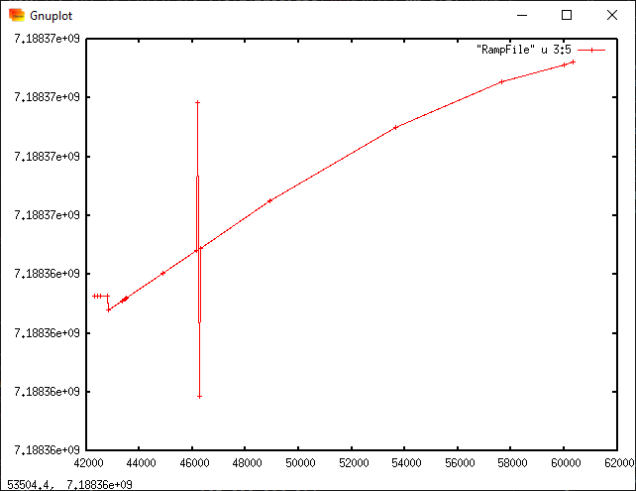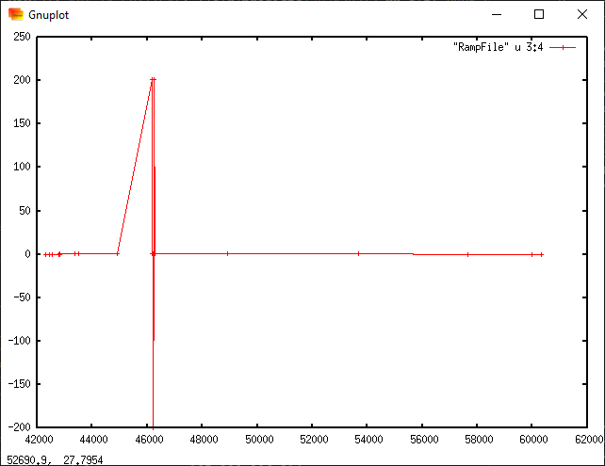
Sky Frequency
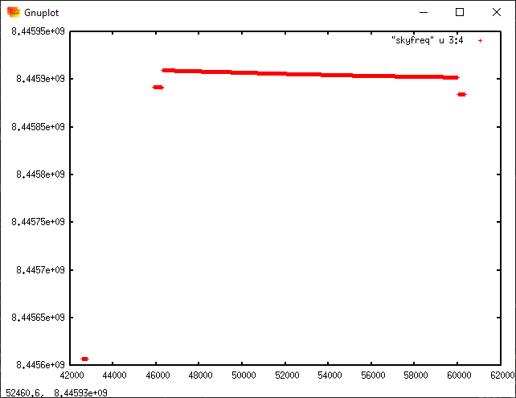

I ran the pds4.tranform tool on the TRK-2-34 data and was able to verify correspondence between the major fields and the output of transform.

The collection CSV and label look good.

Sky Frequency

The sky frequency files contain information that would be needed for gravity science investigation, and the label clearly identifies the relevant fields.

The table descriptions in the label are consistent with the fields in the data file.

The collection CSV and label look good.

Some questions and minor corrections follow for L25TNFXL02_DPX_220820628_00.xml:

- <Observation Area><Primary_Result_Summary><description>
skyfrequency sky frequency

- “The SOURCE_PRODUCT_ID mentioned in the label header above links to the different data files used for processing of the DOPPLER output file. …” Where is this?

<Field_Character>
<name>TRANSMIT FREQUENCY RAMP REFERENCE TIME</name>
<field_number>6</field_number>
<field_location unit="byte">86</field_location>
<data_type>ASCII_Date_Time_YMD</data_type>
<field_length unit="byte">23</field_length>
<field_format>%23s</field_format>
<description>The time (t0) at which the transmitted frequency would have been
f_0 using the coefficients f_0 (column 7) and df (column 8). At any time t
within the interval when those coefficients are valid, the transmitted
frequency f_t may be calculated from </description> Text leaves off abruptly
</Field_Character>

- Field 10 <description>
Earths neutral atmosphere. Earth’s
the calculation include calculation includes
Earths ionosphere Earth’s ionosphere

ION

The file is in the expected *.CSP format. The label lid_reference refers to the necessary documentation.

The collection CSV and label look good.

SFF

The values in the table match the descriptions provided in the label.

The collection CSV and label look good.

Some questions and minor corrections follow for lcy_r_230216_230217_v01.xml:

- “The Small Forces File (SFF) provides to JPL's Orbit Determination Program (ODP)…” This the old program. Either add or update to MONTE.

- DMASS – it isn’t defined what this variable actually is. Like the missions listed, will it always be zero for Lucy?

<Field_Delimited>
<name>DMASS</name>
<field_number>7</field_number>
<data_type>ASCII_Real</data_type>
<unit>kg</unit>
<description>Always zero for MPL, GNS, M01, DIF, MRO, PHX, Juno, GRA, GRB,
MAVEN, and ORX files.</description>
</Field_Delimited>

- ACS1_ACC_ON_TIME – only for thruster 1?

<Field_Delimited>
<name>ACS16_ACC_ON_CMDS</name>
<field_number>30</field_number>
<data_type>ASCII_Real</data_type>
<description>Number of firings during the accumulation period for ACS Thruster
16</description>
</Field_Delimited>
<Field_Delimited>
<name>ACS1_ACC_ON_TIME</name>
<field_number>31</field_number>
<data_type>ASCII_Real</data_type>
<unit>ms</unit>
<description>Accumulated ON time during the accumulation period for the ACS
Thruster 1</description> Remove “the”
</Field_Delimited>

