Lucy Dinkinesh Data Review – Radio Science

Reviewer: Daniel Kahan
Jet Propulsion Laboratory
Planetary Radar and Radio Sciences Group (PRRSG)
Date: September 23, 2024

Executive Summary

The Lucy radio science bundle (urn:nasa:pds:lucy.rss) was reviewed. The contents include DSN tracking files (TRK-2-34), ionosphere calibration files (ION), small forces files (SFF), and sky frequency files (skyfreq). The SIS for radio science, not previously provided at the pipeline review, is now available.

The files are readable and well documented. The main items that should be addressed are as follows:
- Various comments regarding the SIS
- Editorial corrections and questions about the labels

Documentation

*Note that the majority of comments herein are based on the originally posted SIS. However, the updates for missing sections have been taken into account.

The spacecraft comm system and antenna characteristics are well explained. The data, therefore, should prove scientifically useful and interpretable.

- Section 2.4.4 states that ASCII files generally end in line feed. SFF and ION files, which do not have the .TAB extension, actually end in in new-line. Perhaps call this out more clearly.
- Section 3.2.1 correct the link to https://pds-geosciences.wustl.edu/radiosciencedocs/urn-nasa-pds-jpl_dsn_mmm/ (missing a hyphen at “pdsjpl”
- Items 4-6 are based on the originally posted SIS. The newly posted SIS, 22668.07-RSS-SIS-01 R0 C1, no longer contains the sky frequency data format description table, which is good to have.
- 3.2.3 Columns 6 and 7 are declared as not used in closed loop mode. However, the data files contain values other than 0000-00-00T00:00:00.000 or -999999999.999999, respectively. Perhaps the data were collected in “open loop” mode? Please clarify.
[kahan@chiron data_dinkinesh_skyfreq]$ head L14TNFXL02_DPX_233051830_00.TAB
00000001 2023-11-01T18:30:06.497 305.77090853 752135475.680000 2.264122 2023-11-01T17:36:27.801 7188358000.631005 -999.999999 8445908395.101487 8445908394.902000 0.002762 0.199487 -126.0 0.000000 -99999.999999 -999.9 -999.9
00000002 2023-11-01T18:30:07.497 305.77092010 752135476.680000 2.264122 2023-11-01T17:36:28.801 7188358001.192585 -999.999999 8445908394.358078 8445908394.229759 0.002762 0.128319 49.0 0.000000 -99999.999999 -999.9 -999.9
- 3.2.3 Column 8 designated as -99999.999999 but data files contain -999.999999
- 3.2.3 Column 14 designated as -999.999999 but data files contain 0.000000
- Acronym List contains several entries that don’t appear in the document.
- Some entries that should be included in the acronym list are TNF and SFF

Collection Logical Identifiers (3.1, Table 3-1)
Looks good

Minor editorial corrections to rss_sis.pdf:

- (2.1) Lucy will encounter a Main Belt asteroid in 2025, and visit its first Trojan asteroid in 2027, and accomplish its remarkable succession of encounters by 2033,

- (2.1.1.1) For SPE angle less than 14 degrees

- (2.1.1.1) For SPEs SPE angles between 14 and 53 degrees

- (2.1.1.1) The LGA is used for SPEs SPE angles greater than 53 degrees.

- (2.1.1.1) when SPE angle is less than 60 degrees

- (2.1.2) Note that the Lucy project has been approved to use of the uplink and downlink X-band
- frequencies/channels assigned to the OSIRIS-REx and MAVEN projects.

- (2.3.4.1) Each of the radio science data products has have a unique naming convention

- (2.3.4.1) The naming convention for the tracking data products (trk-2-34) products are is

Naming Conventions (section 2.3.4.1):

Tracking data – consistent with data files

Ionosphere media calibration – consistent with data files

Small forces – consistent with data files

Sky frequency – consistent with data files

Please clarify the use of “TNF” throughout the document. It is the extension for TRK-2-34 files, assumed to mean “Tracking and Navigation File” (though that is not stated). It is also included in the naming for sky frequency files, presumably meaning the same thing. However, if so, how is it known from “TNFX” that the data are two-way? “rrrr = receiver system; TNFX = Trac-2-34 two-way single X-band.” Perhaps only 2-way data were used in the creation of the sky frequency files. If so, no need to mention 2-way in the naming convention. Just reserve discussion for section 3.2.3 describing the sky frequency files.

Data

TRK-2-34

Using the PRRSG’s software tools, summary information and data (uplink ramps and sky frequency) were extracted from a sample file as follows:

[kahan@chiron data_dinkinesh_trk234]$ trk234_info2 -p -m lucy_2023_306_054512_2023_306_155000_53.tnf
0% 100%
*****************************
Report for File: lucy_2023_306_054512_2023_306_155000_53.tnf
Generation Date: 2024-255T04:31:13
Start Time: 2023-306T05:45:12
End Time: 2023-306T15:50:00
Spacecraft ID: 49
Downlink DSS ID: 53
Downlink Bands: X
Doppler Count Time: 10.0
Uplink DSS ID: 53
Uplink Bands: X
Tracking Mode: 1W, None, 3W/35, 2W
Number of Records: 107157
Data Description IDs: C123, C125, C124
Available Data Types: 0, 1, 2, 3, 7, 9, 11, 16, 17
00: Uplink Carrier Phase - 36284
01: Downlink Carrier Phase - 32190
02: Uplink Sequential Ranging Phase - 31524
03: Downlink Sequential Ranging Phase - 232
07: Sequential Ranging - 232
09: Ramps - 29
11: DRVID - 232
16: Carrier Observable - 3217
17: Total Phase Observable - 3217

DSS-53 X-band Downlink:
DCC 10 None @ 2023-306T05:50:28 - 2023-306T05:54:01 (Final Loop BW = 10.0 Hz)
DCC 10 3W/35 @ 2023-306T06:45:06 - 2023-306T07:23:42 (Final Loop BW = 10.0 Hz)
DCC 10 1W @ 2023-306T07:25:06 - 2023-306T07:44:21 (Final Loop BW = 10.0 Hz)
DCC 10 2W @ 2023-306T07:45:18 - 2023-306T15:40:20 (Final Loop BW = 10.0 Hz)

Ramp Frequency Ramp Rate
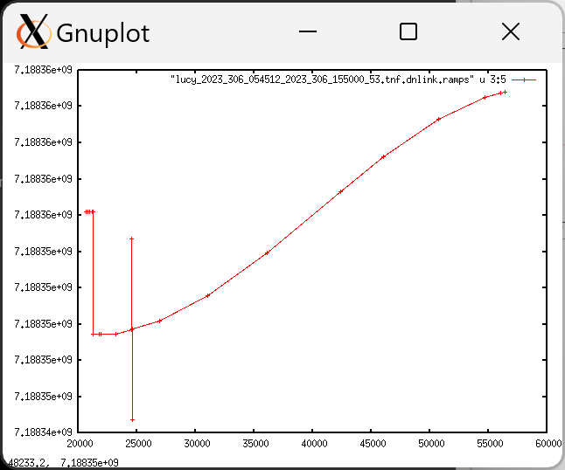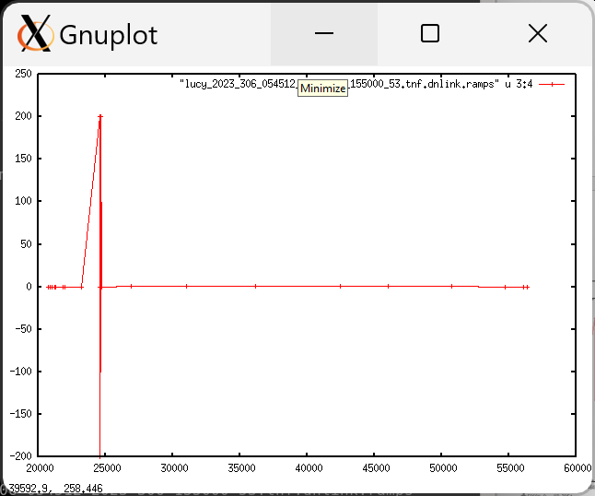
Sky Frequency
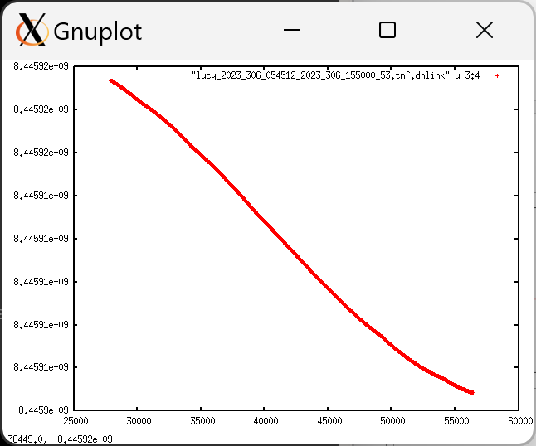

I ran the pds4.tranform tool on the TRK-2-34 data and was able to verify correspondence between the major fields and the output of transform.

- Collection CSV has a typo - P,urn:nasa:pds:lucy.rss:data_dinkinesh_trk234:collectin_inventory::1.0

- Collection_overview.txt refers to .tnf text files but trk-2-34 files are not text.

Sky Frequency

The sky frequency files contain information that would be needed for gravity science investigation, and the label clearly identifies the relevant fields.

The table descriptions in the label are consistent with the fields in the data file.

The collection files and labels look good.

One question follows for L14TNFXL02_DPX_233051830_00.xml:

- “The SOURCE_PRODUCT_ID mentioned in the label header above links to the different data files used for processing of the DOPPLER output file. …” Where is this?

ION

The files are in the expected *.CSP format. The label lid_reference refers to the necessary documentation.

The collection files and labels look good.

SFF

The values in the table match the descriptions provided in the label.

The collection files and labels look good.

One question follows for lcy_r_230829_230904_v01.xml:

- DMASS – it isn’t defined what this variable actually is. Like the missions listed, will it always be zero for Lucy?

<Field_Delimited>
<name>DMASS</name>
<field_number>7</field_number>
<data_type>ASCII_Real</data_type>
<unit>kg</unit>
<description>Always zero for MPL, GNS, M01, DIF, MRO, PHX, Juno, GRA, GRB,
MAVEN, and ORX files.</description>
</Field_Delimited>

