Lucy Donaldjohanson Data Review – Radio Science

Reviewer: Daniel Kahan
Jet Propulsion Laboratory
Planetary Radar and Radio Sciences Group (PRRSG)
Date: October 16, 2025

Executive Summary

The Lucy radio science bundle (urn:nasa:pds:lucy.rss), was reviewed, specifically the Donaldjohanson collections. The contents include DSN tracking files (TRK-2-34), ionosphere calibration files (ION), small forces files (SFF), and sky frequency files (skyfreq). The Software Interface Specification for radio science, previously reviewed for Dinkinesh, was referenced.

The files are readable and well documented. There are no new items that need to be addressed. Some items from the previous review pertaining to the documentation remain. They are listed here for reference but are not new.

Documentation

Since the SIS was previously reviewed, the only additional check is for aspects pertaining to Donaldjohanson. The mission phase is referenced once, in Table 3-1, and the rest of the material applies generically as it did for Dinkinesh.

The spacecraft comm system and antenna characteristics are well explained. The data, therefore, should prove scientifically useful and interpretable.

- Section 2.4.4 states that ASCII files generally end in line feed. However, SFF and ION files, two of the three text type files, actually end in in new-line. The simplest resolution would be to simply delete the second sentence, which is grammatically incorrect anyway. “ASCII or UTF-8 text file generally, line endings are line-feed.”
- Section 3.2.1 correct the link to https://pds-geosciences.wustl.edu/radiosciencedocs/urn-nasa-pds-jpl_dsn_mmm/ (missing a hyphen at “pdsjpl”
- Items 4-6 are based on the originally posted SIS. The newly posted SIS, 22668.07-RSS-SIS-01 R0 C1, no longer contains the sky frequency data format description table, which is good to have.
- 3.2.3 Columns 6 and 7 are declared as not used in closed loop mode. However, the data files contain values other than 0000-00-00T00:00:00.000 or -999999999.999999, respectively. Perhaps the data were collected in “open loop” mode? Please clarify.
[kahan@chiron data_donaldjohanson_skyfreq]$ [kahan@hylonome data_donaldjohanson_skyfreq]$ head -1 L14TNFXL02_DPX_251110100_00.TAB
00000001 2025-04-21T01:00:06.504 111.04174194 798469275.690000 2.067990 2025-04-21T00:35:14.351 7189294166.671234 -999.999999 8444825858.725343 8444825858.772241 -0.025616 -0.046898 -122.2 0.000000 -99999.999999 -999.9 -999.9

- 3.2.3 Column 8 designated as -99999.999999 but data files contain -999.999999
- 3.2.3 Column 14 designated as -999.999999 but data files contain 0.000000
- Acronym List contains several entries that don’t appear in the document.
- Some entries that should be included in the acronym list are TNF and SFF

Collection Logical Identifiers (3.1, Table 3-1)
Looks good

Minor editorial corrections to rss_sis.pdf:

- (2.1) Lucy will encounter a Main Belt asteroid in 2025, and visit its first Trojan asteroid in 2027, and accomplish its remarkable succession of encounters by 2033,

- (2.1.1.1) For SPE angle less than 14 degrees

- (2.1.1.1) For SPEs SPE angles between 14 and 53 degrees

- (2.1.1.1) The LGA is used for SPEs SPE angles greater than 53 degrees.

- (2.1.1.1) when SPE angle is less than 60 degrees

- (2.1.2) Note that the Lucy project has been approved to use of the uplink and downlink X-band
- frequencies/channels assigned to the OSIRIS-REx and MAVEN projects.

- (2.3.4.1) Each of the radio science data products has have a unique naming convention

- (2.3.4.1) The naming convention for the tracking data products (trk-2-34) products are is

Naming Conventions (section 2.3.4.1):

Tracking data – consistent with data files

Ionosphere media calibration – consistent with data files

Small forces – consistent with data files

Sky frequency – consistent with data files

Data

TRK-2-34

Using the PRRSG’s software tools, summary information and data (uplink ramps and sky frequency) were extracted from a sample file as follows:

[kahan@hylonome data_donaldjohanson_trk234]$ trk234_info2 -p -m lucy_2025_100_085013_2025_100_145500_36.tnf
0% 100%
*****************************
Report for File: lucy_2025_100_085013_2025_100_145500_36.tnf
Generation Date: 2025-281T21:19:23
Start Time: 2025-100T08:50:13
End Time: 2025-100T14:55:00
Spacecraft ID: 49
Downlink DSS ID: 36
Downlink Bands: X
Doppler Count Time: 10.0
Uplink DSS ID: 36
Uplink Bands: S, X
Tracking Mode: None, 1W, 2W
Number of Records: 62813
Data Description IDs: C123, C125, C124
Available Data Types: 0, 1, 2, 3, 7, 9, 11, 16, 17
00: Uplink Carrier Phase - 21883
01: Downlink Carrier Phase - 18789
02: Uplink Sequential Ranging Phase - 18010
03: Downlink Sequential Ranging Phase - 116
07: Sequential Ranging - 116
09: Ramps - 29
11: DRVID - 116
16: Carrier Observable - 1877
17: Total Phase Observable - 1877

DSS-36 X-band Downlink:
DCC 06 None @ 2025-100T08:55:15 - 2025-100T08:59:01 (Final Loop BW = 10.0 Hz)
DCC 06 1W @ 2025-100T09:35:06 - 2025-100T10:02:20 (Final Loop BW = 10.0 Hz)
DCC 06 2W @ 2025-100T10:03:15 - 2025-100T14:45:21 (Final Loop BW = 10.0 Hz)

Ramp Frequency Ramp Rate
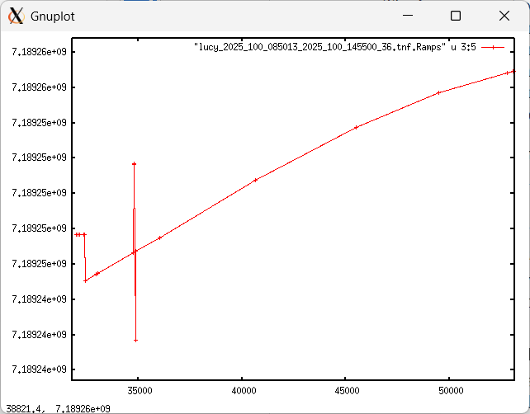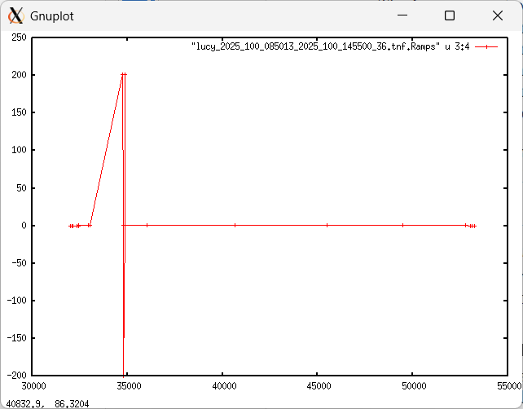
Sky Frequency
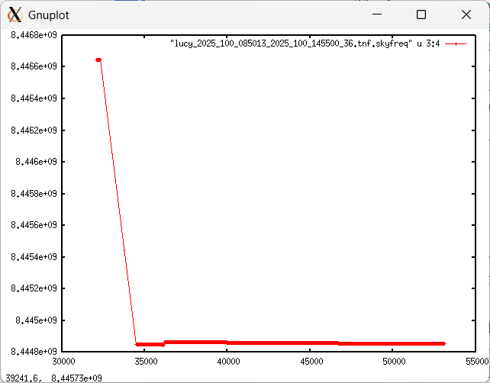

I ran the pds4.tranform tool on the TRK-2-34 data and was able to verify correspondence between the major fields and the output of transform.

Sky Frequency

The sky frequency files contain information that would be needed for gravity science investigation, and the label clearly identifies the relevant fields.

The table descriptions in the label are consistent with the fields in the data file.

The collection files and labels look good.

Skyfreq data only cover 9 passes near the Flyby on DOY 110, whereas TNF data cover DOYs 100 to 117.

One question follows for L24TNFXL02_DPX_251100201_00.xml as an example:

- “The SOURCE_PRODUCT_ID mentioned in the label header above links to the different data files used for processing of the DOPPLER output file. …” Where is this?

ION

The files are in the expected *.CSP format. The label lid_reference refers to the necessary documentation.

The collection files and labels look good.

SFF

The values in the table match the descriptions provided in the label.

The collection files and labels look good.

